
  Ministry of Foreign Affairs
  C GEN. DIRECTORATE FOR EUROPEAN AFFAIRS
  C4 Directorate Justice, Home Affairs &
  Schengen
  Email: g04@mfa.gr
  www.mfa.gr
Ministry of Interior &
Administrative Reconstruction
Directorate General for Citizenship &
Immigration Policy
Directorate for Immigration Policy
Email: tada1.metanastefsi@ypes.gr
www.ypes.gr

Visa & Residence Permit guide for students

Index

- EU/EEA Nationals

- Non EU/EEA Nationals
2.a Mobility of Non EU/EEA Students
- Moving between EU countries during my short-term visit – less than three months
- Moving between EU countries during my long-term stay – more than three months
2.b Short courses in Greek Universities, not exceeding three months.
2.c Admission for studies in Greek Universities or for participation in exchange programs, under bilateral agreements or in projects funded by the European Union i.e “ERASMUS + (placement)” program for long-term stay (more than three months).
- Studies in Greek universities (undergraduate, master and doctoral level
- Participation in exchange programs, under interstate agreements, in cooperation projects funded by the European Union including «ERASMUS+ placement program»

- Refusal of a National Visa (type D)/Rights of the applicant.

- Right to appeal against the decision of the Consular Authority

5. Annex I - Application form for National Visa (sample)
Annex II - Application form for Residence Permit
Annex III - Refusal Form
Annex IV - Photo specifications for a national visa application

Annex V - Aliens and Immigration Departments Contacts

- Students EU/EEA Nationals
You will not require a visa for studies to enter Greece if you possess a valid passport from an EU Member State, Iceland, Liechtenstein, Norway or Switzerland. However, please check your passport is valid and if necessary, renew it as early as possible, and before leaving for Greece.

- Students, non EU/EEA Nationals

2.a Short term and long term Mobility of Non EU/EEA Students

Moving between EU countries during my short-term visit – less than three months
When you stay in an EU country for a long stay for studies, for more than three months, you will generally be issued with a national long-stay visa and/or a residence permit. If your long-stay visa or permit has been issued by a Schengen area country, you can travel to another Schengen area country for three months per six-month period without any additional visa.

Moving between EU countries during my long-term stay – more than three months
To continue your studies from one Schengen area country to Greece for more than three months, you will need a Greek Residence Permit. If you wish to continue your studies to Greece, you may enter with your valid passport and residence permit and submit an application for a residence permit to your closest “One-Stop Service” Foreigners and Immigration Department of the Decentralized Administration of the Ministry of Interior & Administrative Reconstruction (Annex V). After the submission of the application, you will receive a certificate (when you submit all necessary documentation / see also point 2c respectively) and you can check at any time the application status.
The supporting documents required (apart from the general requirements of national immigration law) are the following:
- A fully completed and signed copy of the harmonized application form for a uniform visa (available at the website of the Consular Authority), accompanied by a recent colour photograph of the applicant meeting the relevant standards set by ICAO (Annex IV).
- A passport or other travel document, recognized by Greece, as indicated in the «Table of travel documents which permit crossing of the external borders and may have a visa attached», with a period of validity which must exceed by three months the last validity date of the visa, having at least two blank pages and issued within the previous ten years (Article 12, paragraph 1, of the Visa Code).
- Travel insurance with a period of validity equal to, at least, the visa issued, covering the costs which might arise in case of repatriation for medical reasons, urgent medical attention and/or emergency hospital treatment.
- A true copy of the residence permit for studies, of which he/she is a holder in another Member State of the European Union
- A confirmation issued by an education establishment of another Member State of the European Union on the curriculum the student has attended in it, as well as on the additional or related nature of this curriculum with the program he/she intends to attend in Greece and its completion time.
- A confirmation issued by the respective program promoter on the participation of the student in a Community or bilateral exchange program or proof from the competent authorities of a Member State of the European Union that he/she has been admitted to it as a student for at least two years or a certificate issued by the education establishment of the other European Union Member State, certifying the compulsory attendance of part of this curriculum in Greece
- Evidence proving that he/she has adequate income to meet study and subsistence costs, the amount of which is at least equal to four hundred (400) euros a month, as defined by the provisions of the Joint Ministerial Decree No. 41712/2014 (Government Gazette No. 2285, issue B’).

2b. Short courses in Greek Universities, not exceeding three months.

-List of third countries whose nationals are exempt from visa requirements when crossing the external borders of Member States of Regulation (EC) No. 539/2001.
-List of third countries whose nationals must have a visa when crossing the external borders of Member States.
Third country nationals wishing to enter Schengen area for a period less than three months, belonging to list of third countries whose nationals must have a visa when crossing the external borders of the Schengen MS, shall visit their competent Consular Authority or the External Service Provider (ESP) and apply for a Schengen Visa (type C). The Visa is free of charge for the following categories:
- school pupils, students, postgraduate students and accompanying teachers who undertake stays for the purpose of study or educational training;
-researchers from third countries travelling for the purpose of carrying out scientific research as defined in Recommendation No 2005/761/EC of the European Parliament and of the Council of 28 September 2005 to facilitate the issue by the Member States of uniform short-stay visas for researchers from third countries travelling within the Community for the purpose of carrying out scientific research.
Third country nationals wishing to enter Schengen area for a period less than three months, belonging to list of third countries whose nationals are exempted from visa requirements, may enter to the Schengen area without any other formality for the respective period.

2c. Admission for studies in Greek Universities or to participate in exchange programs, under bilateral agreements or in projects funded by the European Union i.e “ERASMUS + (placement)” program for long-term stay – more than three months.

If your passport is from a country outside the EU/EEA, then you will need to apply for a Student Visa (national visa type D) and after your admission to Greece for a Residence Permit.
http://www.mfa.gr/en/appendix/greece-bilateral-relations/a.html -Greek Consular Authorities (VISA):
“One-Stop Service” Aliens and Immigration Department of the Decentralized Administration of the Ministry of Interior & Administrative Reconstruction (RESIDENCE PERMIT).

To issue a residence permit, a substantial and necessary requirement is the possession, by all persons concerned, of a specific national visa. This requirement applies regardless of whether the country issuing the travel document of the person concerned belongs to those of List of third countries whose nationals must have a visa when crossing the external borders of Member States or List of third countries whose nationals are exempt from visa requirements when crossing the external borders of Member States of Regulation (EC) No. 539/2001
National visas does not automatically confer further rights (e.g. to study), but should be accompanied by a relevant certificate proving the lodging of an application (with all the necessary documentation) to issue a residence permit. A residence permit is the legal document providing the necessary certification from the competent Greek authorities and based on which the third - country national is allowed to stay legally in the Greek territory and have all rights provided for in the national immigration legislation. Any third - country national holding a long - term visa issued by a Member State and having a period of validity of up to one year, may travel to other Member States for 90 days, within any period of 180 days, under the same terms applying to holders of residence permits.

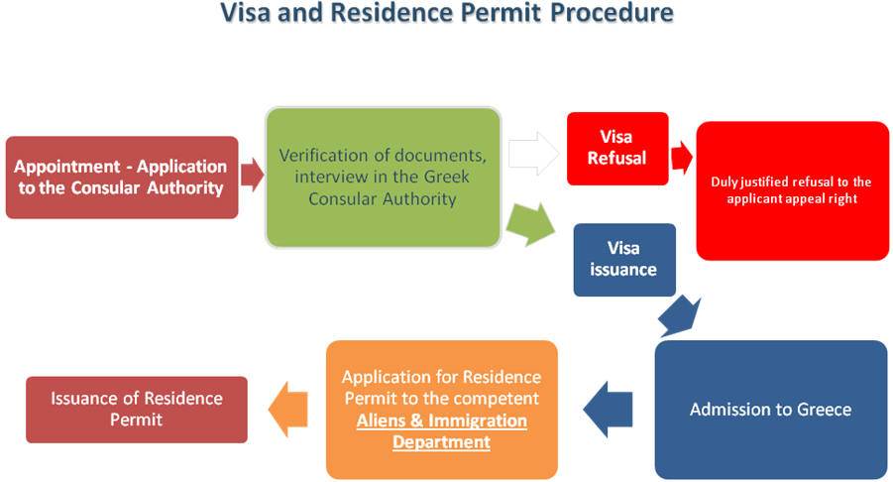

Studies in Greek universities (undergraduate, master and doctoral level)
Type of Visa: National-D (Category “D.1.1 Studies”)

Third country nationals who have been admitted to a higher education establishment in Greece, in order to attend a full-time curriculum in Greece, may be provided, upon physical presence at the Greek Consular Authority and a corresponding interview, a national visa valid for up to 365 days and then issue a residence permit valid until the end of their studies.
The supporting documents required are the following:
- A certificate proving registration and payment of fees at the respective education establishment, as appropriate, or a certificate that he/she has been accepted for registration
- Evidence proving that they have adequate income to meet study and subsistence costs, amounting to at least four hundred (400) euros a month. The amount of sufficient income is proved by a deposit account, a bank transfer, a scholarship or a proof of salary in case the student is employed part time (upon renewal of the residence permit)
- Consent of the parents or the person exercising parental authority for the planned stay, if under 18 years of age
- When the curriculum to be attended by the third - country national requires sufficient knowledge of the Greek language, as a prerequisite for his/her registration, the relevant education establishment shall make the necessary checks and issue the corresponding certificate, which shall be presented to the competent Greek Consular Authority.
- A fully completed and signed application form for a long - term national visa, accompanied by a recent colour photograph of the applicant, which must meet the relevant standards provided by the International Civil Aviation Organization (ICAO). The application form stands for the statutory declaration, provided by paragraph 6, Article 22 of Act 1599/1986, that the data reported are true and the supporting documents are not forged or falsified.
- A passport or other recognized travel document meeting the following criteria: a) its validity exceeds by at least three months the intended date of departure from the territory of the Enhanced Schengen Cooperation Member - States or, in case of more than one visits, after the last intended date of departure from the territory of the Member - States; however, under reasoned urgent circumstances, this obligation may be lifted; b) it has at least two blank pages; c) it has been issued within the previous decade 46.
- Criminal record certificate issued by the foreign authorities, certifying the criminal status of the applicant in the country of his/her residence. In cases where the applicant lives in a country different from that of his/her origin, for more than a year before lodging the entry visa application, the Consular Authority may, request the presentation of a criminal record certificate issued by the country of origin.
- Medical certificate issued by a recognized state or private institution, showing that the person concerned does not suffer from a disease capable of constituting a risk to public health, according to the international data of the World Health Organization (WHO) and the European Union acquis, as well as other infectious, contagious or parasitic diseases, imposing the taking of measures to protect public health;
- Travel insurance, with a duration equal to, at minimum, that of the visa issued, covering the costs which may arise in case of repatriation for medical reasons, for urgent medical care and/or for emergency hospital care.
- Visa Fee (90 euros).
In order to establish that there are no grounds for refusing entry under paragraph 2, Article 4 of Law 4251/2014, the competent Consular Authority may require that additional supporting documents are filed.

For the Residence Permit the Student shall submit the following supporting documents to the Aliens and Immigration Department:

- A certificate proving registration and payment of fees at the respective education establishment, as appropriate, or a certificate that he/she has been accepted for registration
- Evidence proving that they have adequate income to meet study and subsistence costs, amounting to at least four hundred (400) euros a month. The amount of sufficient income is proved by a deposit account, a bank transfer, a scholarship or a proof of salary in case the student is employed part time (upon renewal of the residence permit)
- Consent of the parents or the person exercising parental authority for the planned stay, if under 18 years of age
- A fully completed and signed application form for a Residence Permit.
- Fee (150 euros per year)

Participation in exchange programs, under interstate agreements, in cooperation projects funded by the European Union including «ERASMUS+ placement program»
Type of Visa: National-D (Category “D.4.3 Participation in special programs”)

D.4.3 Participation in special programs
Third - country nationals participating in exchange programs, under interstate agreements, in cooperation projects funded by the European Union or in the «ERASMUS+ program», may be issued, upon physical presence and a corresponding interview, a national visa a national visa valid for up to 365 days and then issue a residence permit valid until the end of the program.
- A certificate from the responsible authority of the program confirming the participation of the third - country national.
- If the program is co-funded by EU (i.e. Erasmus + placement) and it includes traineeship in the subject of the studies, it is required a contract between the university that participates in the program, the student and the public or private entity.
- A fully completed and signed application form for a long - term national visa, accompanied by a recent colour photograph of the applicant, which must meet the relevant standards provided by the International Civil Aviation Organization (ICAO). The application form stands for the statutory declaration, provided by paragraph 6, Article 22 of Act 1599/1986, that the data reported are true and the supporting documents are not forged or falsified.
- A passport or other recognized travel document meeting the following criteria: a) its validity exceeds by at least three months the intended date of departure from the territory of the Enhanced Schengen Cooperation Member - States or, in case of more than one visits, after the last intended date of departure from the territory of the Member - States; however, under reasoned urgent circumstances, this obligation may be lifted; b) it has at least two blank pages; c) it has been issued within the previous decade 46.
- Criminal record certificate issued by the foreign authorities, certifying the criminal status of the applicant in the country of his/her residence. In cases where the applicant lives in a country different from that of his/her origin, for more than a year before lodging the entry visa application, the Consular Authority may, request the presentation of a criminal record certificate issued by the country of origin.
- Medical certificate issued by a recognized state or private institution, showing that the person concerned does not suffer from a disease capable of constituting a risk to public health, according to the international data of the World Health Organization (WHO) and the European Union acquis, as well as other infectious, contagious or parasitic diseases, imposing the taking of measures to protect public health;
- Travel insurance, with a duration equal to, at minimum, that of the visa issued, covering the costs which may arise in case of repatriation for medical reasons, for urgent medical care and/or for emergency hospital care.
- Visa Fee (90 euros).
In order to establish that there are no grounds for refusing entry under paragraph 2, Article 4 of Law 4251/2014, the competent Consular Authority may require that additional supporting documents are filed.

For the Residence Permit third-country shall submit the following supporting documents to the Aliens and Immigration Department:

- A certificate from the responsible authority of the program confirming the participation of the third - country national.
- If the program is co-funded by EU (i.e. Erasmus + placement) and it includes traineeship in the subject of the studies, it is required a contract between the university that participates in the program, the student and the public or private entity.
- A fully completed and signed application form for a Residence Permit.
- Fee (150 euros per year)

- Refusal of a National Visa
The Greek Consular Authority may refuse to issue a National Visa (type D), if the requirements are not met and the necessary supporting documents are not filed, as provided by Greek national legislation. In particular when
- a false/counterfeit/forged travel document was presented.
- a non recognized travel document by Greece was presented
- the travel document does not ensure return to the country of origin or nationality or to a third country
- false or counterfeit documents were presented
- it was not possible to ascertain and/or prove the purpose and terms of your stay
- you have used misleading/deceiving information with the Consular Authority.
- an alert has been issued in the Schengen Information System (SIS) for the purpose of refusing entry.
- you are included in the list of third - country nationals who are prohibited from entering Greece
- pursuant to Article 82 of Act 3386/2005.
- you may be a threat to the public order and security or to public health.
- you are involved in a migrant trafficking network.
- Other reasons duly justified by the Consul.
In the above cases there is an obligation on the part of the Consular Authority to provide to the applicant, a written and well-reasoned confirmation for the rejection of the visa application, maintaining on file a signed, by the rejected person, copy, which is considered a necessary and essential component of a legality audit of the decision taken by the Consular Authority.

- Right to appeal against the decision of the Consular Authority

The applicant may appeal against this decision before the competent administrative court, pursuant to article 15 of Law 3068/2002 (National Gazette A’ 274), within 90 days of the date on which you have been served herewith or notified hereof.
The appeal must be written in Greek and signed by a Greek lawyer or yourself. If you choose to sign it yourself, a Greek lawyer must attend the hearing thereof.
Appeals sent by post shall not be admitted.

Annex I - National visa application form

 |  | APPLICATION FOR A VISA FOR A LONG – TERM STAY IN GREECE  THIS APPLICATION FORM IS FREE OF CHARGE |  | PHOTO
1 | SURNAME (FAMILY NAME)
2 | GIVEN NAME(S) (GIVEN NAME(S)
3 | SURNAME AT BIRTH
4 | FORMER FAMILY NAME(S)
5 | DATE OF BIRTH  (DAY-MONTH-YEAR)
6 | PLACE OF BIRTH
7 | COUNTRY OF BIRTH
8 | CURRENT NATIONALITY
9 | NATIONALITY AT BIRTH, IF DIFFERENT FROM CURRENT:
10 | SEX |  | MALE
10 |  |  | FEMALE
11 | MARITAL STATUS |  | SINGLE
11 |  |  | MARRIED
11 |  |  | SEPARATED
11 |  |  | DIVORCED
11 |  |  | WIDOW(ER)
11 |  |  | OTHER  (PLEASE SPECIFY)
12 | IN CASE OF MINORS -  DETAILS OF PARENTAL AUTHORITY/LEGAL GUARDIAN |  | SURNAME
12 |  |  | GIVEN NAME
12 |  |  | ADDRESS  (IF DIFFERENT FROM APPLICANT'S)
12 |  |  | NATIONALITY
13 | NATIONAL IDENTITY NUMBER  (WHERE APPLICABLE)
14 | TYPE OF TRAVEL DOCUMENT |  | ORDINARY PASSPORT
14 |  |  | DIPLOMATIC PASSPORT
14 |  |  | SERVICE PASSPORT
14 |  |  | SPECIAL PASSPORT
14 |  |  | OFFICIAL PASSPORT
14 |  |  | OTHER TRAVEL DOCUMENT  (PLEASE SPECIFY)
15 | NUMBER OF TRAVEL DOCUMENT
16 | DATE OF ISSUE OF TRAVEL DOCUMENT
17 | TRAVEL DOCUMENT VALID UNTIL
18 | TRAVEL DOCUMENT ISSUED BY
19 | APPLICANT'S HOME ADDRESS
20 | APPLICANT'S E-MAIL ADDRESS
21 | APPLICANT'S TELEPHONE NUMBER
22 | RESIDENCE IN A COUNTRY OTHER THAN THE COUNTRY OF CURRENT NATIONALITY |  | NUMBER OF RESIDENCE PERMIT OR EQUIVALENT
22 |  |  | RESIDENCE PERMIT OR EQUIVALENT VALID UNTIL
23 | CURRENT OCCUPATION

24 | MAIN PURPOSE OF THE JOURNEY | RESIDENCE – FAMILY REUNION
24 | MAIN PURPOSE OF THE JOURNEY | RESIDENCE FOR EMPLOYMENT PURPOSES
24 | MAIN PURPOSE OF THE JOURNEY | STUDIES, RESEARCH, TRAINEESHIP, VOCATIONAL TRAINING
24 | MAIN PURPOSE OF THE JOURNEY | RESIDENCE – COMPANY STAFF
24 | MAIN PURPOSE OF THE JOURNEY | RESIDENCE – INDEPENDENT FINANCIAL ACTIVITY – INVESTMENT
24 | MAIN PURPOSE OF THE JOURNEY | ACCREDITATION
24 | MAIN PURPOSE OF THE JOURNEY | OTHER  (PLEASE SPECIFY)
25 | INTENDED DATE OF ARRIVAL IN GREECE
26 | APPLICANT’S ADDRESS IN GREECE
A | DATA OF THE INDIVIDUAL RESIDENT IN GREECE IN CASE OF APPLYING FOR A RESIDENCE VISA FOR FAMILY REUNION
27 | SURNAME (FAMILY NAME) OF THE RESIDENT INDIVIDUAL IN GREECE
28 | GIVEN NAME(S) (GIVEN NAME(S)) OF THE RESIDENT INDIVIDUAL IN GREECE
29 | DATE OF BIRTH OF THE RESIDENT INDIVIDUAL IN GREECE
30 | NATIONALITY OF THE RESIDENT INDIVIDUAL IN GREECE
31 | NUMBER OF THE RESIDENCE PERMIT OF THE RESIDENT INDIVIDUAL IN GREECE
32 | NUMBER OF PASSPORT OF THE RESIDENT INDIVIDUAL IN GREECE
33 | INDIVIDUAL RESIDENT’S ADDRESS IN GREECE
34 | INDIVIDUAL RESIDENT’S TELEPHONE
35 | INDIVIDUAL RESIDENT’S E-MAIL ADDRESS
36 | FAMILY RELATIONSHIP  (OF THE APPLICANT WITH THE INDIVIDUAL RESIDENT IN GREECE) | SPOUSE
36 |  | CHILD OF THE INDIVIDUAL RESIDENT
36 |  | CHILD OF HIS/HER SPOUSE
36 |  | OTHER (PLEASE SPECIFY)
B | DATA OF THE EMPLOYER OR THE COMPANY IN CASE OF APPLYING FOR A RESIDENCE VISA FOR EMPLOYMENT PURPOSES, INCLUDING SEASONAL WORK
37 | SURNAME (FAMILY NAME) OF THE EMPLOYER OR NAME OF THE COMPANY
38 | GIVEN NAME(S) (GIVEN NAME(S)) OF THE EMPLOYER OR NAME OF THE COMPANY
39 | SURNAME (FAMILY NAME) OF THE CONTACT PERSON IN THE COMPANY
40 | GIVEN NAME(S) (GIVEN NAME(S)) OF THE CONTACT PERSON IN THE COMPANY
41 | EMPLOYER OR COMPANY’S ADDRESS
42 | EMPLOYER OR COMPANY’S TELEPHONE
43 | EMPLOYER OR COMPANY’S E-MAIL ADDRESS
44 | GREEK RESIDENCE PERMIT OR GREEK’S IDENTITY CARD OF THE EMPLOYER OR OF THE CONTACT PERSON IN THE COMPANY
45 | COMPANY’S GREEK TAX NUMBER

C | DATA OF THE EDUCATIONAL ESTABLISHMENT OR RESEARCH CENTRE IN CASE OF APPLYING FOR STUDIES OR RESEARCH PURPOSES, TRAINEESHIP OR VOCATIONAL TRAINING
46 | NAME OF THE EDUCATIONAL ESTABLISHMENT OR RESEARCH CENTRE
47 | ADDRESS OF THE EDUCATIONAL ESTABLISHMENT OR RESEARCH CENTRE
48 | TELEPHONE OF THE EDUCATIONAL ESTABLISHMENT OR RESEARCH CENTRE
49 | E-MAIL ADDRESS OF THE EDUCATIONAL ESTABLISHMENT OR RESEARCH CENTRE
50 | INTENDED DATE OF START OF STUDIES OR RESEARCH
51 | INTENDED DATE OF END OF STUDIES OR RESEARCH
52 | I am aware of and consent to the following: the collection of the data required by this application form and the taking of my photograph and, if applicable, the taking of fingerprints, are mandatory for the examination of the visa application; and any personal data concerning me which appear on the visa application form, as well as my fingerprints and my photograph will be supplied to the relevant authorities and processed by those authorities, for the purposes of a decision on my visa application.  Such data as well as data concerning the decision taken on my application or a decision whether to annul, revoke or extend a visa issued will be entered into, and stored in the Visa Information System (VIS) for a maximum period of five years, during which it will be accessible to the visa authorities and the authorities competent for carrying out checks on visas at external borders and within the Member States, immigration and asylum authorities in the Member States for the purposes of verifying whether the conditions for the legal entry into, stay and residence on the territory of the Member States are fulfilled, of identifying persons who do not or who no longer fulfil these conditions, of examining an asylum application and of determining responsibility for such examination. Under certain conditions the data will be also available to designated authorities of the Member States and to Europol for the purpose of the prevention, detection and investigation of terrorist offences and of other serious criminal offences. The authority of Greece responsible for processing the data is: Ministry of Citizen Protection, Greek Police, International Police Cooperation Division, 3rd Division SIRENE, 4 Kanellopoulou St. GR– 101 77 Athens, Tel.:+30.210.6977000, Fax:+30.210.6929764, Email: info@sirene-gr.com  I am aware that I have the right to obtain notification of the data relating to me recorded in the Visa Information System and to request that data relating to me which are inaccurate be corrected and that data relating to me processed unlawfully be deleted. At my express request, the authority examining my application will inform me of the manner in which I may exercise my right to check the personal data concerning me and have them corrected or deleted, including the related remedies according to the national legislation of the State concerned. The national supervisory authority (Hellenic Data Protection Authority, 1-3 Kifisias ave., 1st floor, GR – 115 23 Athens, Tel.: +30.210.6475600, Fax:+30.210.6475628, E-mail: contact@dpa.gr} will hear claims concerning the protection of personal data.  I declare that to the best of my knowledge all particulars supplied by me are correct and complete. I am aware that any false statements will lead to my application being rejected or to the annulment of a visa already granted and may also render me liable to prosecution.  I have been informed that possession of a visa is only one of the prerequisites for entry into the European territory of the Member States. The mere fact that a visa has been granted to me does not mean that I will be entitled to compensation if I fail to comply with the relevant provisions of Article 5(1) of Regulation (EC) No 562/2006 (Schengen Borders Code) and I am therefore refused entry. The prerequisites for entry will be checked again on entry into the European territory of the Member States.
53 | I AM AWARE THAT THE VISA FEE IS NOT REFUNDED IF THE VISA IS DENIED
54 | PLACE
55 | DATE
56 | SIGNATURE  (FOR MINORS, SIGNATURE OF PARENTAL AUTHORITY/LEGAL GUARDIAN

Annex II - Application Form for Residence Permit

You can find on line the application form for Residence Permit here:

http://www.ypes.gr/UserFiles/f0ff9297-f516-40ff-a70e-eca84e2ec9b9/110form.pdf

Annex III - Refusal Form

Embassy/
Consulate General/
Consulate of Greece…
Sidney, March 14th 2001

REFUSAL OF NATIONAL VISA REQUEST
Dear Madam/ Dear Sir {NAME-SURNAME}
{THE EMBASSY/ CONSULATE GENERAL/ CONSULATE OF GREECE IN ...........
Has examined your application for long - term visa and has refused by virtue of article 18 of the Convention Implementing the Schengen Agreement of June 19th, 1990, sanctioned by Act 2514/1997 (Government Gazette No. 140/Α/27.06.1997, p. 5735) which was amended with the Article 1, paragraph 1 of the Regulation (EU) No 265/2010 of March, 25th, 2010, amending the Convention Implementing the Schengen Agreement and Regulation (EC) No 562/2006 as regards movement of persons with a long-stay visa and the Article 8 of the Act 3386/2005 on the entry, residence and social inclusion of third - country nationals on Greek territory, and the addendum of Article 4, paragraph 3 of the Act 3875/2010.
This decision is based on the following reason(s):
1. |  | a false/counterfeit/forged travel document was presented.
2. |  | a non recognized travel document by Greece was presented.
3. |  | the travel document does not ensure return to the country of origin or nationality or to a third country.
4. |  | false or counterfeit documents were presented.
5. |  | it was not possible to ascertain and/or prove the purpose and terms of your stay.
6. |  | you have used misleading/deceiving information with the Consular Authority.
7. |  | an alert has been issued in the Schengen Information System (SIS) for the purpose of refusing entry.
8. |  | you are included in the list of third - country nationals who are prohibited from entering Greece
 |  | pursuant to Article 82 of Act 3386/2005.
9. |  | you may be a threat to the public order and security or to public health.
10. |  | you are involved in a migrant trafficking network.
11. |  | [OTHER DETAILED REASONS FILLED OUT BY THE CONSULATE OR FURTHER
 |  | SPECIFICATION OF THE REASONS STATED ABOVE].
Remarks
Comments: You may appeal against this decision before the competent administrative court, pursuant to article 15 of Act 3068/2002 (National Gazette A’ 274), within 90 days of the date on which you have been served herewith or notified hereof.
The appeal must be written in Greek and signed by a Greek lawyer or yourself. If you choose to sign it yourself, a Greek lawyer must attend the hearing thereof.
You may also lodge the appeal before a Greek authority.
Appeals sent by post shall not be admitted.e
(DATE, SIGNATURE AND STAMP OF CONSULAR AUTHORITY).
You have been issued with a copy hereof.
(DATE, NAME AND SIGNATURE OF APPLICANT).

Annex IV - Photo specifications for a national visa application
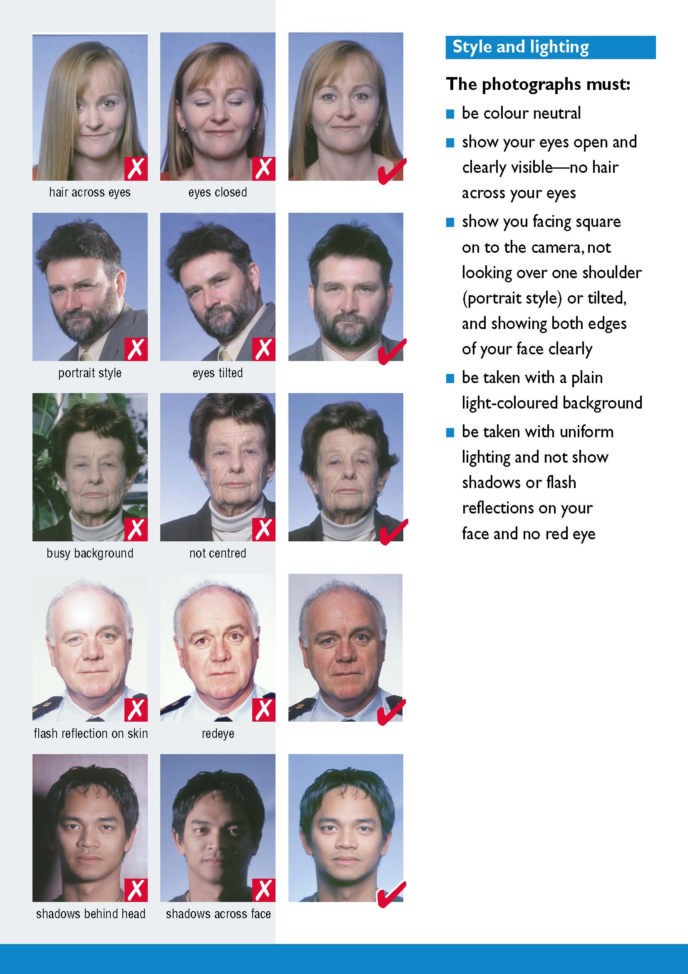

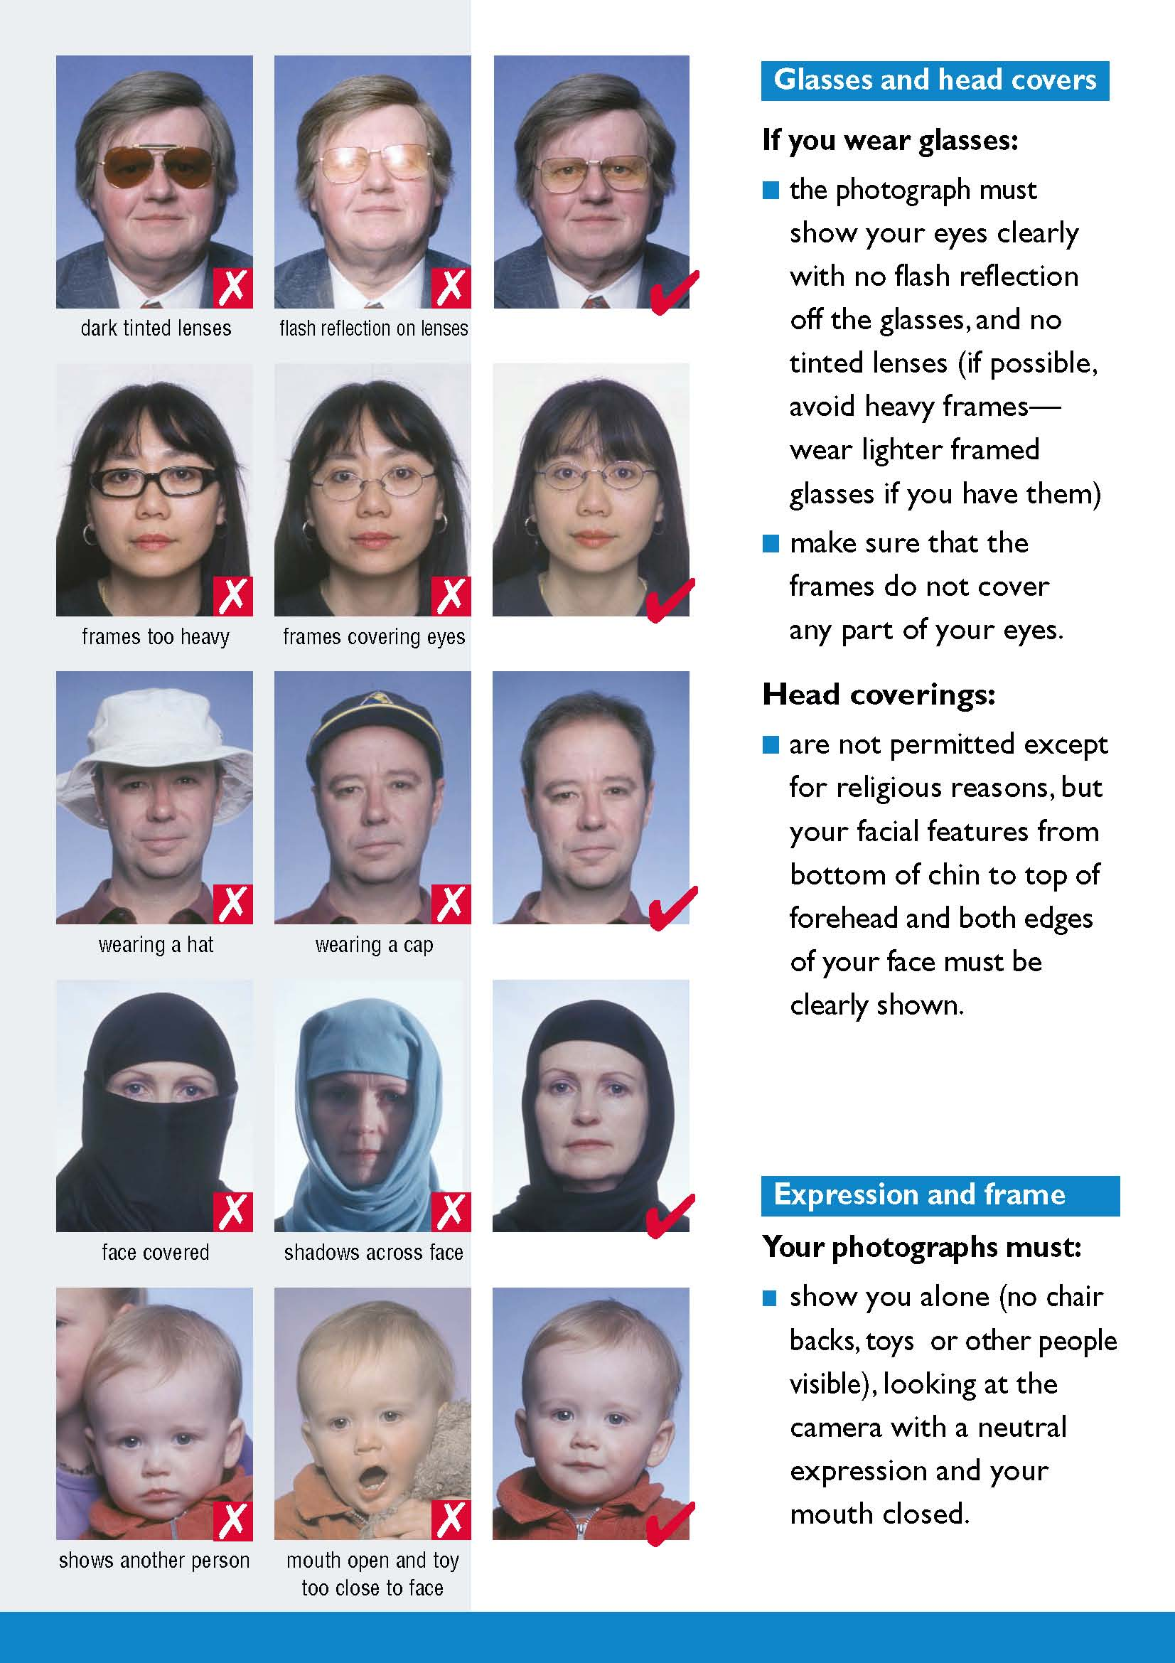

Annex V - Aliens and Immigration Departments Contacts
S / N | Aliens and Immigration Directorate or Department | Competence for third - country nationals residing in the Municipalities | Address / phone / fax | E-mail
DECENTRALIZED ADMINISTRATION OF ATTICA
1 | ATHENS A’ | Athens | 2 SALAMINIAS & PETROU RALLI ST., 118 55 ATHENS GREECE TEL.: 210 3403350 FAX: 210 3403357 & 358 | dam_athinas@attica.gr
2 | CENTRAL SECTOR & WEST ATTICA | a) Vyronas, b) Galatsi, c) Dafni-Ymittos d) Zografou, e) Ilioupoli, f) Kaisariani g) Filadelfeia-Chalkidon, h) Agia Varvara i) Agii Anargyroi-Kamatero, j) Egaleo k) Ilion, l) Peristeri m) Petroupoli, n) Chaidari, o) Aspropyrgos, p) Elefsina, q) Mandra-Eidyllia, r) Megara, s) Fyli | 2 SALAMINIAS & PETROU RALLI ST., 118 55 ATHENS TEL.: 2103403300 FAX: 2103403355 & 2103403356 | dam_kd@attica.gr
3 | SOUTH SECTOR, PIRAEUS & ISLANDS | a) Agios Dimitrios, b) Alimos, c) Glyfada d) Elliniko-Argyroupoli e) Kallithea, f) Moschato-Tavros, g) Nea Smyrni h) Palaio Faliro, i) Keratsini-Drapetsona, j) Korydallos, a ) Nikaia-Agios Ioannis Rentis, l) Piraeus m) Perama, n) Agkistri o) Aigina, p) Kythira, q) Poros, r) Salamina s) Spetses k) Troizina, l) Ydra | 5 AGIOS DIONYSIOS ST., 185 45 PIRAEUS TEL.: 210 4141600 FAX: 210 4141655 | dam_dattip@attica.gr
4 | NORTH & EAST SECTOR OF ATTICA | a) Agia Paraskevi, b) Maroussi, c) Vrilissia d) Irakleio, e) Kifissia, f) Lykovrysi - Pefki, g) Metamorfosih) Nea Ionia, i) Papagou-Cholargos, j) Penteli k) Filothei -Psychiko, l) Chalandri m) Acharnes, n) Vari-Voula-Vouliagmeni, o) Dionysos, p) Kropia, q) Lavrio, s) Marathonas, k) Markopoulo-Mesogaia, etc) Paiania, v) Pallini, w ) Pikermi Rafina, x) Saronic y) Spata-Artemida, z) Oropos | 19 PSARRON St, 153 51 PALLINI TEL.: 210 6604900 FAX: 210 6604945 - 210 6604925 | dam_anat@attica.gr
DECENTRALIZED ADMINISTRATION OF WEST GREECE, PELOPONNESE & IONIAN ISLANDS
 | ACHAIA | a) Patras, b) Erymanthos c) West Achaia, d) Kalavryta, e) Aigialeia | 55 NEW NATIONAL ROAD PATRAS – ATHENS, 264 41 PATRAS TEL.: 2610 425330, 436726 FAX: 2610461554 | dam@apd-depin.gov.gr
6 | AITOLIA & AKARNANIA | a) Agrinio, b) Aktio-Vonitsa, c) Xiromero d) Nafpaktia e) Amfilochia f) Mesolongi g) Thermo | 37 KYPROU ST., 302 00 MESOLONGI TEL.: 26310 26625 FAX: 26310 26640 | tadmesolo@apd-depin.gov.gr
7 | ARGOLIDA | a) Nafplio, b) Ermionida c) Epidavros d) Argos- Mykines | 28 25TH MARCH ST., 211 00 NAFPLIO TEL.: 27520 27053 FAX: 27520 27063 | yam-arg@otenet.gr
8 | ARCADIA | a) Tripoli, b) South Kynouria c) Gortynia d) Megalopoli, e) Kynouria | 17 – 21 GEORGIOU A' ST., 221 00 TRIPOLI TEL .: 2710 225307 FAX: 2710 225307 | tad.ark@1747.syzefxis.gov.gr
9 | ZAKYNTHOS | Zakynthos | D. ROMA XENIA 291 00 ZAKYNTHOS TEL.: 26950 42448 FAX: 26950 42448 | allodzak@otenet.gr
10 | ILEIA | a) Zacharo, b) Andritsaina-Krestena c) Pyrgos, d) Ilida e) Ancient Olympia, f) Andravida-Kyllini g) Pineios | 11 ARCHIMIDOUS ST., 271 00 PYRGOS TEL.: 26210 29522, 29573 FAX: 26210 29572 | tadhleias@4944.syzeyxis.gov.gr
11 | KERKYRA (CORFU) | a) Kerkyra, b) Paxoi | ALYKES POTAMOU 491 00 KERKYRA TEL.: 26613 61587 FAX: 26610 48302 | tadk@1745.syzefxis.gov.gr
12 | KEFALONIA | b) Kefalonia, b) Ithaki | 160 L.VERGOTI ST., 281 00 ARGOSTOLI TEL.: 26710 26382 FAX: 26710 29304 | tad-kef@5053.syzefxis.gov.gr
13 | KORINTHIA | a) Korinthos, b) Sikyon c) Xylikastro-Evrostina d) Velo- Vocha e) Loutraki-Agii Theodori f) Nemea | 93 AP.PAVLOU ST., 201 00 KORINTHOS TEL.: 27410 73705 FAX: 27410 73708 | tadk@apd-depin.gov.gr
14 | LAKONIA | a) Sparti, b) East Mani, c) Evrotas, d) Monemvasia e) Elafonisos | GOVERNMENT HOUSE, 2nd KM GYTHIO - SPARTI NATIONAL ROAD, SPARTI 00 231 TEL.: 27313 63448 FAX: 27313 63441 | lakadm@1747.syzefxis.gov.gr
15 | LEFKADA | a) Lefkada b) Meganisi | 9 PEFANEROMENIS & KARAISAKI ST., 311 00 LEFKADA TEL.: 26450 25252 FAX: 26450 26544 | tad@5161.syzefxis.gov.gr
16 | MESSINIA | a) Kalamata b) Messini c) Pylos-Nestoras d) Triphylia e) Oichalia f) West Mani | 173 ATHINON ST., 241 00 KALAMATA TEL.: 27210 96575 FAX: 27210 86225 | tad-mes@5186.syzefxis.gov.gr
DECENTRALIZED ADMINISTRATION OF CRETE
17 | HERAKLION | a) Irakleio, b) Malevizi c) Archanes-Asterousia d) Faistos e) Gortyna f) Chersonisos, g) Minoa Pediada h) Viannos | 2 ELEFTHERNIS & SYVRITOU ST., 713 03 CRETE TEL.: 2810 264168 FAX: 2810 264160 | allodap@apdkritis.gov.gr
18 | LASITHI | a) Agios Nikolaos, b) Sitia c) Ierapetra, d) Oropedio Lasithiou | 1 IROON POLYTECHNEIOU ST., - GOVERNMENT HOUSE, 721 00 AGIOS NIKOLAOS TEL.: 28410 25289 FAX: 28410 25289 | tadlas@apdkritis.gov.gr
19 | RETHYMNO | a) Rethymno, b) Mylopotamos c) Amari d) Agios Vasileios, e) Anogia | 6 APOLONIATOU ST., 741 00 RETHYMNO TEL.: 28310 20800 FAX: 28310 23085 | m.neonakis@apdkritis.gov.gr
20 | CHANIA | a) Chania, b) Apokoronou c) Platanias d) Kissamos e) Kantanos- Selino, f) Gavdos g) Sfakia | 27 THERAPEFTIRIOU ST., 732 00 CHANIA TEL.: 28210 28310, 811 FAX: 28210 23820 | allodaph@apdkritis.gov.gr
DECENTRALIZED ADMINISTRATION OF MACEDONIA - THRACE
21 | THESSALONIKI | a) Thesaloniki, b) Kordelio-Evosmos c) Neapolis-Sykies, d) Pavlou Mela, e) Ampelokipoi-Menemeni f) Pylaia-Chortiatis g) Halkida, h) Delta i) Oreokastro j) Lagadas, k ) Thermaikos l) Thermi, m) Volvi, n) Kalamaria | 1 TAKIS ECONOMIDES ST., 540 08 THESSALONIKI TEL.: 2313 309202 FAX: 2313 309205 | dam-the@damt.gov.gr
22 | DRAMA | a) Drama, b) Prosotsani c) Paranesti d) Doxato, e) Kato Nevrokopi | GOVERNMENT HOUSE 661 00 DRAMA TEL.: 25213 51 504 - 6 FAX: 25213 51508 | tad-dra@damt.gov.gr
23 | EVROS | a) Alexandroupoli b) Soufli c) Didymoteicho d) Orestiada, e) Samothraki | 1B MAKRIS ST., NEA CHILI, ALEXANDROUPOLI 681 00 TEL.: 25510 84792 FAX: 25510 84780 | tad-evr@damt.gov.gr
24 | IMATHIA | a) Veroia, b) Alexandreia, c) Naoussa | 89 VENIZELOU ST., 591 00 VEROIA TEL.: 23310 75165 FAX: 23310 75197 | tad-hma@damt.gov.gr
25 | KAVALA | a) Kavala, b) Nestos c) Pangaio d) Thassos | 2 ELEFTHERIAS ST., 654 03 KAVALA TEL.: 2510 221273 FAX: 2510 221387 | tad-kav@damt.gov.gr
26 | KILKIS | a) Kilkis, b) Paionia | 21 ETHNIKIS ANTISTASIS ST., 611 00 KILKIS TEL.: 23410 29272 FAX: 23410 29273 | tad-kil@damt.gov.gr
27 | XANTHI | a) Xanthi, b) Myki, c) Avdira d) Topeiros | 9 CHR.SMYRNIS ST., 671 00 XANTHI TEL.: 2313 309770-6 FAX: 25410 63272 | tad-xan@damt.gov.gr
28 | PELLA | a) Edessa, b) Almopia c) Skydra d) Pella | GOVERNMENT HOUSE 582 00 EDESSA TEL.: 23810 51245 FAX: 23810 23220 | tad-pel@damt.gov.gr
29 | PIERIA | a) Dion-Olympos b) Pydna-Kolindros c) Katerini | 41 KITROUS ST., 601 00 KATERINI TEL.: 23510 74444 FAX: 23510 46479 | tad-pie@damt.gov.gr
30 | RODOPI | a) Komotini b) Iasmos c) Maroneia-Sapes, d) Arrianoi | EKTENEPOL BLOCK 6 691 00 KOMOTINI TEL.: 25310 31225 FAX: 25310 36712 | tad-rod@damt.gov.gr
31 | SERRES | a) Sintiki b) Visaltia c) Emmanuel Pappas d) Amphipolis e) Nea Zichni f) Irakleia g) Serres | 67 MERARCHIAS ST., 621 00 SERRES TEL .: 2313 309 681 FAX: 23210 97921 | tad-ser@damt.gov.gr
32 | CHALKIDIKI | a) Polygyros b) Sithonia c) Kassandra d) Nea Marmara, e) Aristotelis | DIMOKRATIAS & 1 AN.PAPANDREOU ST., POLYGYROS 631 00 TEL.: 23710 21584 FAX: 23710 21746 | tad-xal@damt.gov.gr
DECENTRALIZED ADMINISTRATION OF EPIRUS - WEST MACEDONIA
33 | IOANNINA | a) Ioannina, b) Zagori c) Konitsa d) Pogoni e) North Tzoumerka f) Metsovo g) Dodoni, h) Zitsa | 62 MARIKAS KOTOPOULI ST., IOANNINA 454 45 TEL.: 26510 88120 FAX: 26510 88112 | -
34 | ARTA | a) Arta, b) Nikolaos Skoufas c) Georgios Karaiskakis d) Central Tzoumerka | PER. ODOS & VENIZELOU, ARTA 471 00 TEL.: 26810 70000 FAX: 26810 78515 | vlioukas@apdhp-dm.gov.gr
35 | GREVENA | a) Deskati b) Grevena | GOVERNMENT HOUSE, END OF K.TALIADOURI ST., GREVENA 511 00 TEL.: 24620 76456 FAX: 24620 76457 | liampasi@apdhp-dm.gov.gr
36 | THESPROTIA | a) Igoumenitsa b) Filiates c) Souli | 20 PARGAS ST., IGOUMENITSA 461 00 TEL.: 26650 21187 FAX: 22650 21191 | adethes@apdhp-dm.gov.gr
37 | KASTORIA | a) Kastoria, b) Orestida c) Nestorio | GOVERNMENT HOUSE KASTORIA 521 00 TEL.: 24670 22672, 22124 FAX: 24670 22254, 22124 | bstankidou@apdhp-dm.gov.gr
38 | KOZANI | a) Kozani, b) Voio c) Eordaia d) Servia-Velvento | ZEP ZONE, W. MACEDONIA REGION BUILDING, KOZANI KOZANI 50100 TEL.: 24610 53548, 53572 FAX: 24613 50285, 6 | www.apdhp-dm.gov.gr
39 | PREVEZA | a) Preveza b) Parga c) Ziros | 1 ETHNIKIS ANTISTASIS ST., 481 00 PREVEZA TEL.: 26820 22460 FAX: 26820 24760 | pkalesoglou@apdhp-dm.gov.gr
40 | FLORINA | a) Florina, b) Amyntaio c) Prespes | 1 PTOLEMAION ST., - GOVERNMENT HOUSE, FLORINA 531 00 TEL.: 23850 49137 FAX: 23850 49136 | migkoufani@apdhp-dm.gov.gr
DECENTRALIZED ADMINISTRATION OF ISLANDS
41 | DODECANESE | a) Rodos b) Karpathos c) Nisyros d) Kasos e) Megistif) Symi g) Tilos h) Chalki | 28-30 IROON POLYTECHNEIOU, RHODES 851 00 TEL.: 22410 28149 22410 75749 FAX: 22410 20707 | r.apostolaki@apdaigaiou.gov.gr
42 | KOS | a) Agathonisi b) Astypalaia c) Kalymnos, d) Kos e) Leipsoi f) Leros g) Patmos | 7 AKTI KOUNTOURIOTI, KOS 85300 TEL.: 22420-30480 | a.mauroleon@kos.gr
43 | CYCLADES | a) Syros- Ermoupolib) Andros c) Tinos d) Kimolos e) Anafi, f) Mykonos g) Kea h) Serifos i) Kythnos j) Sifnos k) Milos | 35 EPTANISOU ST., ERMOUPOLI SYROS 84 100 TEL.: 22810 84105 FAX: 22810 88043 | tm_akamsyr_na@1191.syzefxis.gov.gr
44 | NAXOS | a) Naxos and Mikres Kyklades b) Paros c) Antiparos d) Amorgos e) Folegandros f) Sikinos g) Thira h) Ios | CHORA NAXOS, NAXOS 843 00 TEL.: 22853-60142, 60103 FAX: 22850-23570
45 | LESVOS | a) Lesvos, b) Limnos c) Agios Efstratios | 1 SMYRNIS ST., MYTILINI 811 00 TEL.: 22510 26971 FAX: 2251037267 | pvadakam@apdaigaiou.gov.gr
46 | SAMOS | a) Samos b) Ikaria c) Fournoi Korseon | THEMISTOKLI SOFOULI & 1 GRAMMOU ST., SAMOS 831 00 TEL .: 2273087878 FAX: 22730 80807 | pvatakams@apdaigaiou.gov.gr
47 | CHIOS | a) Chios b) Oinousesc) Psara | 66 MICHAIL LIVANOU ST., CHIOS 821 00 TEL.: 22710 41063 FAX: 22710 42778 | pvatakamx@apdaigaiou.gov.gr
DECENTRALIZED ADMINISTRATION OF THESSALY - CENTRAL GREECE
48 | LARISSA | a) Elassona, b) Farsala c) Agia, d) Tempi, e) Tyrnavos f) Larissa, g) Kileler | 111 SOKRATOUS ST., 413 36 LARISSA TEL.: 2413 503659 FAX: 2413 503653 | alodlar@apdthest.gov.gr
50 | VOIOTIA | a) Tanagra, b) Thiva, c) Aliartos d) Orchomenos e) Livadeia f) Distomo-Arachova-Antikyra | 8-10 DODEKANISOU ST. LIVADEIA 321 00 TEL.: 22610 23857, 23858, 23865 FAX: 22610 23856 | tad_viotias@apdthest.gov.gr
51 | EVIA | a) Chalkida, b) Dirfyon-Messapion c) Eretria d) Karystos e) Istiaia-Aidipsos f) Mantoudi-Limni-Agia Anna g) Kymi-Aliveri h) Skyros | 2 VELISSARIOU ST., CHALKIDA 341 00 TEL.: 22210 88879 FAX: 22210 78730 | tad_evias@apdthest.gov.gr
52 | EVRYTANIA | a) Karpenisi b) Agrafa | 3 NAP. ZERVA ST., KARPENISI 361 00 TEL.: 22370 80739 FAX: 22370 80765 | tad_evryt@apdthest.gov.gr
53 | KARDITSA | a) Argithea b) Limni Plastira c) Palamas d) Sofadesn e) Karditsa f) Mouzaki | 140 SARANTAPOROU ST., KARDITSA 431 00 TEL.: 24410 79826 FAX: 24410 23645 | tad@apdthest.gov.gr
54 | MAGNISSIA | a) Volos, b) Rigas c) Zagora-Mouresi d) Almyros e) South Pilio, f) Alonnisos g) Skiathos h) Skopelos | 95 DIMITRIADOS ST., VOLOS 382 22 TEL.: 24210 76798 FAX: 24210 76010 | tad_magnisia@apdthest.gov.gr
55 | TRIKALA | a) Pyli b) Farkadona c) Trikala, d) Kalambaka | 30 KOLOKOTRONI ST., TRIKALA 421 00 TEL.: 24310 39420 FAX: 24310 39513 | tad_trikala@apdthest.gov.gr
49 | FTHIOTIDA | a) Amfikleia-Elateia, b) Lokroi c) Domokos, d) Molos-Agios Konstantinos e) Stylida f) Lamia, g) Makrakomi | 3 MARKOU BOTSARI ST., LAMIA 351 00 TEL.: 22310 30932-3 FAX: 22310 30934 | tad_fthiotidas@apdthest.gov.gr
56 | FOKIDA | a) Delphi, b) Dorida | 9 STALLOU ST., 331 00 AMFISSA TEL.: 22650 22062 FAX: 22650 23815, 22 062 | tad_fokidas@apdthest.gov.gr
57 | MINISTRY OF INTERIOR / SECRETARIAT-GENERAL OF POPULATION AND SOCIAL COHESION / DIRECTORATE: MIGRATION POLICY | SPECIAL CATEGORIES OF RESIDENCE PERMITS | SUBMISSION OF APPLICATIONS: 5 AG. DIONYSIOU ST., PIRAEUS, 18545, TEL.: 210 4141641, 210 4141671, FAX: 2131361239 | t.gypp@ypes.gr

True translation of the Greek original document.
Athens, 2/6/2015 The translato

The applicant shall present a valid travel document satisfying the following criteria: a. its validity shall extend at least three months after the intended date of departure from the territory of the Member States or, in the case of several visits, after the last intended date of departure from the territory of the Member States. However, in a justified case of emergency, this obligation may be waived; b. it shall contain at least two blank pages; c. it shall have been issued within the previous 10 years.
Consular territorial competence: -An application shall be examined and decided on by the consulate of the competent Member State in whose jurisdiction the applicant legally resides. -A consulate of the competent Member State shall examine and decide on an application lodged by a third-country national legally present but not residing in its jurisdiction, if the applicant has provided justification for lodging the application at that consulate. Competence to issue visas to third-country nationals legally present within the territory of a Member State: Third-country nationals who are legally present in the territory of a Member State and who are required to hold a visa to enter the territory of one or more other Member States shall apply for a visa at the consulate of the Member State that is competent in accordance with Article 5(1) or (2).
A long - term visa 39 (National visa - D Type Visa) is an authorization issued by the competent Greek authorities for the entry and stay of third - country nationals in the Greek territory for a period exceeding 90 days and up to 365 days, according to the respective national regulations or European Union law on the residence status of third - country nationals.
Accelerated visa and residence permit procedure for postgraduate students As provided for in Article 37 of Act 4251/2014 Greek Universities shall take all appropriate steps to accelerate the procedure, for issuing visas and residence permits to graduate students. ¹⁵⁰ Higher education institutions of the country operating postgraduate curricula may conclude contracts for setting up an accelerated issuing procedure for residence permits to postgraduate students, third - country nationals, with the Ministry of Interior, if special reasons exist and under the following conditions: a. The duration of the postgraduate program exceeds three (3) months. b. The necessary supporting documents are filed. Accelerated procedure contracts include the exact title of the postgraduate program and mention the specific reasons existing for concluding the contract, its duration and the possibility of renewal, as well as the obligations of the contracting parties.
In the beginning of each academic year (September) the Ministry of Education, Research and Religious Affairs transmits to the Greek Consular Authorities the Decree on the «Validation of tables of those admitted to Faculties/Directions of Studies in Higher Education Schools of the special category Third - Country Nationals - Aliens and Graduates of High Schools or equivalent schools of the Member States of the European Union, of non - Greek origin» with full names – identity particulars of the Third - Country Nationals – Aliens, so that, provided that the other conditions for entry are met, the relevant student visas are issued, as appropriate.
In accordance with the data in the travel document.
In accordance with the data in the travel document.
In so far as the VIS is operational.

