Courses taught in English by the Department of Forestry and Natural Environment Management

for Erasmus students

List of courses taught in English for Erasmus students:

Winter semester
Total available ECTS: 40

Geology - Mineralogy - Petrography
1st Semester, ECTS = 5
Geographic Information Systems of the Environment
3rd Semester, ECTS = 6
Forest Mensuration
5th Semester, ECTS = 6
Forest roads engineering
5th Semester, ECTS = 6
Forest Fires
9th Semester, ECTS = 6
Forest and Environmental Policy
9th Semester, ECTS = 5
Agroforestry
9th Semester, ECTS = 6

Spring Semester
Total available ECTS: 35

Biometry
2nd Semester, ECTS = 5
Technical Drawing
2nd Semester, ECTS = 5
Climate change and forest ecosystems
4th Semester, ECTS = 3
Forest Botany (Geobotany)
4th Semester, ECTS = 5
Forest Economics
4th Semester, ECTS = 6
Forest Entomology
6th Semester, ECTS = 5
Silviculture
6th Semester, ECTS = 6

ERASMUS+ Departmental Coordinator: Palaiologos Palaiologou
E-mail: palaiologou@aua.gr

COURSE DESCRIPTION

Winter semester 4
GEOLOGY - MINERALOGY - PETROGRAPHY 5
GEOGRAPHIC INFORMATION SYSTEMS OF THE ENVIRONMENT 6
FOREST MENSURATION 7
FOREST ROADS ENGINEERING 8
FOREST FIRES 9
FOREST AND ENVIRONMENTAL POLICY 10
AGROFORESTRY 11
Spring semester 12
BIOMETRY 13
TECHNICAL DRAWING 14
CLIMATE CHANGE AND FOREST ECOSYSTEMS 15
FOREST BOTANY (GEOBOTANY) 16
FOREST ECONOMICS 17
FOREST ENTOMOLOGY 18
SILVICULTURE 19

Winter semester

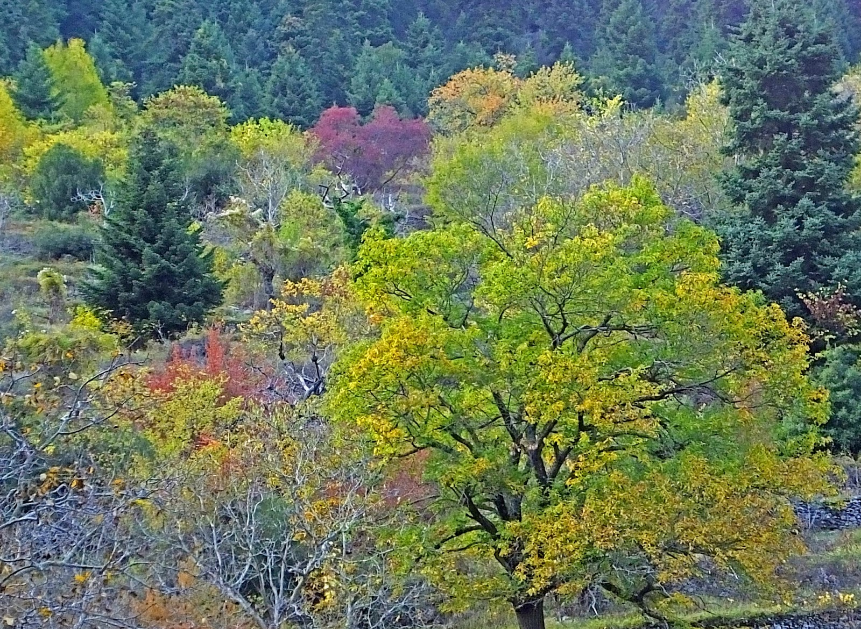
Autumn in Paleos, Evrytania

GEOLOGY - MINERALOGY - PETROGRAPHY

Title: | Geology - Mineralogy - Petrography |  | Check
 |  | Compulsory
ECTS Credits: | 5 | Elective | ..
Course Code: | 114 | Semester | 1
Lecturer: | Stavroula Galanopoulou | Autumn Term
Contact Details: | sgalanop@aua.gr | Spring Term | ..

PREREQUISITES: None

COURSE GOALS
The aim of the course is to study the structure and composition of the Earth's interior, the geological cycles and geological time, the endogenous and exogenous forces as well as the study of the main minerals and rocks that make up the solid crust of the Earth. In this context, the main petro genetic minerals and their physical properties are studied, as well as their way of formation, the properties and classification of igneous, sedimentary and metamorphic rocks.
COURSE CONTENTS |  |  | Total Hrs
1. | Geology: structure and composition of the earth's interior. Geological cycles and geological time. Endogenous and exogenous forces. |  | 14
2. | Mineralogy: crystallographic elements, physical properties and systematic classification of minerals. Identification of most important minerals in hand specimen. |  | 14
3. | Petrography: formation, properties, and classification of igneous, sedimentary and metamorphic rocks. Identification of most important rocks in hand specimen. |  | 14
4. | Use of the petrographic microscope for the identification of minerals and rocks. |  | 6
5. | Geological data of Greece, study of geological maps. |  | 4

TEACHING METHOD |  |  |  | EXAMINATION
Hours |  |  |  |  | Weight
Class | 12 |  |  | Written exam | 50%
Seminar | 12 |  |  | Orals | 0%
Collaboration with lecturer | 4 |  |  | Personal assignments | 50%
Laboratory | 24 |  |  | Group assignments | 0%
TOTAL Hours: | 52 |  |  | TOTAL: | 100%

SUGGESTED BIBLIOGRAPHY | - C. Klein, A. Philpotts, 2017. Earth Materials: Introduction to Mineralogy and Petrology 2nd Edition, Cambridge University Press.  - Swapan Kumar Haldar, 2020. Introduction to Mineralogy and Petrology (Edition 2), Elsevier Inc.  - European journal of mineralogy: https://pubs.geoscienceworld.org/eurjmin  - American mineralogist: https://pubs.geoscienceworld.org/ammin  - Lithosphere: https://pubs.geoscienceworld.org/lithosphere  - Geology: https://pubs.geoscienceworld.org/geology
NOTES | The class/seminar part of the course will be offered in English in a class comprised only of Erasmus+ students. The Laboratory will be offered in a mixed classroom (Erasmus+ and Greek students.

GEOGRAPHIC INFORMATION SYSTEMS OF THE ENVIRONMENT

Title: |  | Geographic Information Systems of the Environment |  |  |  |  |  | Check
 |  |  | Compulsory
ECTS Credits: |  | 6 | Elective |  |  |  |  | ..
Course Code: |  | 312 | Semester |  |  |  |  | 3
Lecturer: |  | Spyridon Kaloudis | Autumn Term
Contact Details: |  | kaloudis@aua.gr | Spring Term |  |  |  |  | ..
PREREQUISITES: None
COURSE GOALS
The aim of this course is the acquisition of theoretical knowledge related to Geographic Information Systems and geographical spatial analysis. The correlation of theoretical knowledge to forestry problems, such as vegetation mapping, forest management studies, and cadastre. Analyzing the process of solving geographical problems, data processing, and decision-making. Take a decision based on the results of the analysis and present the results in the form of maps and diagrams, independently or as part of a comprehensive study.
COURSE CONTENTS |  |  |  |  |  |  | Total Hrs
1. | Introduction to Geographic Information Systems, Cartography – Projection Systems, Basic concepts of GIS. |  |  |  |  |  | 13
2. | Maps and Digitizing methods. |  |  |  |  |  | 21
3. | Databases, and data management. |  |  |  |  |  | 9
4. | Pre-analytical procedures. |  |  |  |  |  | 11
5. | Space Analysis and Decision making. |  |  |  |  |  | 11

TEACHING METHOD |  |  |  | EXAMINATION
Hours |  |  |  |  | Weight
Class | 12 |  |  | Written exam | 50%
Seminar | 21 |  |  | Orals
Collaboration with lecturer | 6 |  |  | Personal assignments | 50%
Laboratory | 26 |  |  | Group assignments
TOTAL Hours: | 65 |  |  | TOTAL: | 100%

SUGGESTED BIBLIOGRAPHY | - Burrough, P.A., and McDonnell, R.A. (1998). Principles of Geographical Information Systems (Oxford), p. 333.  - Heywood, I., Cornelius, S., and Carver, S. (2002). An Introduction to Geographical Information Systems. (Prentice Hall), p. 296.  - Johnston, C. (2005). Geographic Information Systems in Ecology (ION), p. 279.  - Paul A. Longley, Michael F. Goodchild, David J. Maguire, David W. Rhind, 2015. Geographic Information Science and Systems 4th Edition. Wiley, p. 496.  - Tasha Wade, Shelly Sommer, 2006. A to Z GIS: An Illustrated Dictionary of Geographic Information Systems 2nd Edition. ESRI, p. 288.  - Zeiler, M. (1999). Modeling Our World: The Esri Guide to Geodatabase Design (ESRI Press), p. 200.
NOTES | The class/seminar part of the course will be offered in English in a class comprised only of Erasmus+ students. The Laboratory will be offered in a mixed classroom (Erasmus+ and Greek students).

FOREST MENSURATION

Title: | Forest Mensuration |  | Check
 |  | Compulsory
ECTS Credits: | 6 | Elective | ..
Course Code: | 311 | Semester | 3
Lecturer: | Dimitris Zianis | Autumn Term
Contact Details: | zianis@aua.gr | Spring Term

PREREQUISITES: None

COURSE GOALS
It is one of the most fundamental disciplines within forest science, since it is the art and science of providing the quantitative information about trees and forest stands necessary for forest management, planning and research. Such measurements are the basis of sustainable harvest calculations for forest resources. The goal of the course is to provide basic knowledge on measuring standing tree dimensions and forest products, estimating tree form and age, measuring and estimating forest stand variables, estimating forest growth and yield and planning national and local scale forest inventories.
COURSE CONTENTS |  |  | Total Hrs
1. | Measurement units and dimensions |  | 11
2. | Measuring forest wood products |  | 11
3. | Measuring and estimating tree dimensions |  | 15
4. | Measuring and estimating stand variables |  | 15
5. | Planning forest inventories |  | 13

TEACHING METHOD |  |  |  | EXAMINATION
Hours |  |  |  |  | Weight
Class | 20 |  |  | Written exam | 70%
Seminar | 10 |  |  | Orals | 0%
Collaboration with lecturer | 9 |  |  | Personal assignments | 30%
Laboratory | 26 |  |  | Group assignments | 0%
TOTAL Hours: | 65 |  |  | TOTAL: | 100%

SUGGESTED BIBLIOGRAPHY | - Kershaw Jr. J.A., Ducey, M.J., Beers, T.W., Husch, B., 2016. Forest Mensuration. John Wiley & Sons, Ltd.  - Avery, T.H. and Burkhart, H., 2001. Forest Measurements. MacGraw-Hill.
NOTES | The class/seminar part of the course will be offered in English in a class comprised only of Erasmus+ students. The Laboratory will be offered in a mixed classroom (Erasmus+ and Greek students.

FOREST ROADS ENGINEERING

Title: | Forest roads engineering |  | Check
 |  | Compulsory
ECTS Credits: | 6 | Elective | ..
Course Code: | 512 | Semester | 5
Lecturer: | Stergios Tampekis | Autumn Term
Contact Details: | stampeki@aua.gr | Spring Term | ..

PREREQUISITES: None

COURSE GOALS
The subject of the course is to provide students with knowledge in the design, construction, maintenance and management of forest roads for the protection and management of forest ecosystems in the light of resilience and adaptation to climate change.
COURSE CONTENTS |  |  | Total Hrs
1. | Forest roads geometric study (technical characteristics concerning horizontal alignment, vertical alignment, cross sections). |  | 11
2. | Corridor planning and design.  Forest road polygon alignment planning.  Forest road centreline alignment planning.  Curves. Forest road alignment width. Cut and fill volumes. |  | 23
3. | Forest roads planning.  Forest road surveying and measurements.  Life cycle analysis, Environmental impacts. |  | 9
4. | Principles of maintenance of forest roads.  GIS and forest roads application. |  | 9
5. | Basic modules of environmental impact of road construction projects  Land uses – natural & anthropogenic ecosystems  Forest roads spatial planning and impacts on natural environment |  | 13

TEACHING METHOD |  |  |  | EXAMINATION
Hours |  |  |  |  | Weight
Class | 13 |  |  | Written exam | 50%
Seminar | 26 |  |  | Orals | 0%
Collaboration with lecturer | 5 |  |  | Personal assignments | 30%
Laboratory | 26 |  |  | Group assignments | 20%
TOTAL Hours: | 70 |  |  | TOTAL: | 100%

SUGGESTED BIBLIOGRAPHY | - Stückelberger, J.A., H.R. Heinimann, and E.C. Burlet. 2006a. Modeling spatial variability in the life-cycle costs of low-volume forest roads. European Journal of Forest Research. 125 (4): 377- 390.  - Heinimann, H. R. (2017). Forest road network and transportation engineering–state and perspectives. Croatian Journal of Forest Engineering: Journal for Theory and Application of Forestry Engineering, 38(2), 188-173.  - Jaafari, A., Pazhouhan, I., & Bettinger, P. (2021). Machine learning modeling of forest road construction costs. Forests, 12(9), 1169.  - Robinson, C., Duinker, P. N., & Beazley, K. F. (2010). A conceptual framework for understanding, assessing, and mitigating ecological effects of forest roads. Environmental Reviews, 18(NA), 61-86.
NOTES | The class/seminar part of the course will be offered in English in a class comprised only of Erasmus+ students. The Laboratory will be offered in a mixed classroom (Erasmus+ and Greek students.

FOREST FIRES

Title: | Forest Fires |  | Check
 |  | Compulsory
ECTS Credits: | 6 | Elective | ..
Course Code: | 913 | Semester | 9
Lecturer: | Palaiologos Palaiologou | Autumn Term
Contact Details: | palaiologou@aua.gr | Spring Term | ..

PREREQUISITES: None

COURSE GOALS
The aim of the course is to introduce fire risk management issues such as prevention planning, operational organization, and impact management. In addition, concepts, parameters and systems on which forest fire prevention and control is based will be taught in relation to the overall planning of human and natural resource management. Fundamental is for students to acquire theoretical and practical knowledge to understand the phenomenon of forest fires and their ecological role in Greece and worldwide. In addition, students will acquire knowledge concerning the prevention of forest fires, their management and extinguishing, their socio-economic and environmental impacts, and the management of burnt areas. Upon the completion of the course, students will be able to classify forest species by their ability to adapt to fires and describe and classify fuel types.
COURSE CONTENTS |  |  | Total Hrs
1. | Methods of arrangement and combinations of forest fire-fighting forces by type and number, depending on the fire environment (vegetation, topography, meteorology) and fire behaviour. Suppression tactics. |  | 12
2. | Fire risk and assessment. Risk reduction measures. Fire behaviour modelling. |  | 21
3. | Fuel, types and properties. Quantification of fuels. |  | 10
4. | Meteorological factors and wildfires - Pyrometeorology |  | 10
5. | Wildfires in Greece and other regions of the world. Fire effects. Fire ecology. |  | 12

TEACHING METHOD |  |  |  | EXAMINATION
Hours |  |  |  |  | Weight
Class | 13 |  |  | Written exam | 50%
Seminar | 26 |  |  | Orals | 0%
Collaboration with lecturer | 5 |  |  | Personal assignments | 30%
Laboratory | 26 |  |  | Group assignments | 20%
TOTAL Hours: | 70 |  |  | TOTAL: | 100%

SUGGESTED BIBLIOGRAPHY | - Pyne, S.J., Andrews, P.L. and Laven, R.D., 1996. Introduction to Wildland Fire, 2nd edition. John Wiley & Sons, Inc., New York.  - Wright, H.A., and A.W. Bailey. 1982. Fire Ecology. John Wiley & Sons, Inc., New York.  - Schroeder, M.J., and C.C. Buck. 1970. Fire Weather. USDA Forest Service, Agriculture Handbook, 360.  - Cheney, P., and A. Sullivan. 1997. Grassfires: Fuel, Weather and Fire Behavior. CSIRO Publishing, Australia.
NOTES | The class/seminar part of the course will be offered in English in a class comprised only of Erasmus+ students. The Laboratory will be offered in a mixed classroom (Erasmus+ and Greek students).

FOREST AND ENVIRONMENTAL POLICY

Title: | Forest and Environmental Policy |  | Check
 |  | Compulsory
ECTS Credits: | 5 | Elective | ..
Course Code: | 914 | Semester | 9
Lecturer: | Dimitra Lazaridou | Autumn Term
Contact Details: | dlazaridou@aua.gr | Spring Term

PREREQUISITES: None

COURSE GOALS
The aim of the course is to introduce basic concepts to the regulation of forest policy. The student will receive knowledge concerning all phases of forest policy process, namely forest policy formulation, implementation and evaluation. The goal of this course is students to be made familiar with approaches applied to forest and environmental policy, such as informational instruments (e.g., advisory services, public relations), economic instruments (e.g., subsidies, certification), and regulatory instruments (e.g., laws, EU directives). In addition, methods and techniques in supporting decision making will be taught. Students will acquire knowledge to manage the conflicts of diverse interests in forests, which should be regulated by means of the appropriate solutions. Upon the completion of the course, students will receive orientation so they can be involved effectively in policy-making.
COURSE CONTENTS |  |  | Total Hrs
1. | Basic concepts to the regulation of forest policy/ Approaches applied to forest and environmental policy |  | 12
2. | Interests and conflicts in the forest sector |  | 8
3. | Public Administration of Nature and Environmental Protection/ Implementation of Regulatory Instruments |  | 12
4. | Associations and political parties |  | 8
5. | Methods and techniques in supporting policy-making |  | 8

TEACHING METHOD |  |  |  | EXAMINATION
Hours |  |  |  |  | Weight
Class | 20 |  |  | Written exam | 50%
Seminar | 15 |  |  | Orals | 0%
Collaboration with lecturer | 4 |  |  | Personal assignments | 30%
Laboratory | 13 |  |  | Group assignments | 20%
TOTAL Hours: | 52 |  |  | TOTAL: | 100%

SUGGESTED BIBLIOGRAPHY | - Hanley, N., Barbier, E.B., 2009. Pricing Nature: Cost-benefit Analysis and Environmental Policy. Edward Elgar, Cheltenham.  - Krott, M., 2005. Forest Policy Analysis. Springer, Dordrecht.  - McDermott, C.L., Cashore, B., Kanowski, P., 2010. Global Environmental Forest Policies. An International Comparison, Earthscan, London.
NOTES | The class/seminar part of the course will be offered in English in a class comprised only of Erasmus+ students. The Laboratory will be offered in a mixed classroom (Erasmus+ and Greek students.

AGROFORESTRY

Title: | Agroforestry |  | Check
 |  | Compulsory
ECTS Credits: | 6 | Elective | ..
Course Code: | 912 | Semester | 9
Lecturer: | Anastasia Pantera | Autumn Term | ..
Contact Details: | pantera@aua.gr | Spring Term

PREREQUISITES: None

COURSE GOALS
This course describes in detail a traditional land use, called agroforestry. The students are introduced to its advantages and disadvantages, its types and applications. Greek and international agroforestry systems and their future applications are described. Also, students undertake a project with actual data (an agroforestry system from their area of origin), which they analyse in its components, its advantages and disadvantages as well as a financial overview.
COURSE CONTENTS |  |  | Total Hrs
1. | Advantages and disadvantages of agroforestry, Biological, Economic and Social Advantages, Biological, Economic and Social Disadvantages |  | 13
2. | Types - Classification of agroforestry systems |  | 12
3. | Classification according to the type of components, Classification according to the layout in the site, Classification according to the succession in time. |  | 12
4. | Review of the relationships between the components of agroforestry systems and between agroforestry and forms of alternative agriculture. Specific applications of agroforestry |  | 13
5. | Role and prospects of agroforestry, Agroforestry in Greece: trends and perspectives. |  | 15

TEACHING METHOD |  |  |  | EXAMINATION
Hours |  |  |  |  | Weight
Class | 9 |  |  | Written exam | 50%
Seminar | 30 |  |  | Orals | 0%
Collaboration with lecturer | 8 |  |  | Personal assignments | 50%
Laboratory | 26 |  |  | Group assignments | 0%
TOTAL Hours: | 73 |  |  | TOTAL: | 100%

SUGGESTED BIBLIOGRAPHY | - P.K. Nair., An Introduction to agroforestry, Kluwer Academic Publisher, https://apps.worldagroforestry.org/Units/Library/Books/PDFs/32_An_introduction_to_agroforestry.pdf  - Schultz, A., V. Papanastasis, T. Katelman, C. Tsiouvaras, S. Kandrelis, A. Nastis. 1987. Agroforestry in Greece. Working Document, Lab. of Range Science, A.U.T., Thessaloniki  - Agroforestry Systems, https://www.springer.com/journal/10457  - Urban Forestry and Urban Greening, https://www.journals.elsevier.com/urban-forestry-and-urban-greening  - Forestry, https://academic.oup.com/forestry
NOTES | The class/seminar part of the course will be offered in English in a class comprised only of Erasmus+ students. The Laboratory will be offered in a mixed classroom (Erasmus+ and Greek students).

Spring semester

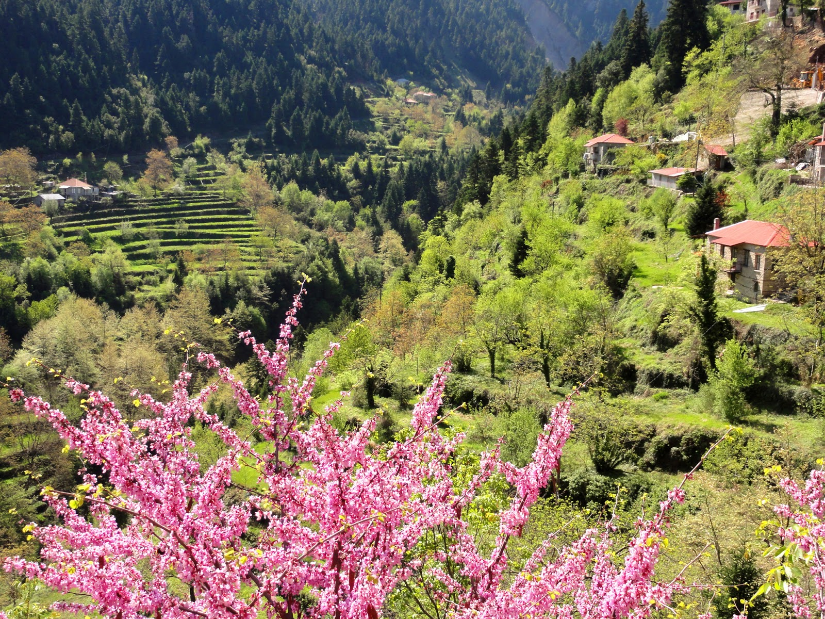
Spring in Tornos, Evrytania

BIOMETRY

Title: | Biometry |  | Check
 |  | Compulsory
ECTS Credits: | 5 | Elective | ..
Course Code: | 211 | Semester | 2
Lecturer: | Dimitris Zianis | Autumn Term
Contact Details: | zianis@aua.gr | Spring Term

PREREQUISITES: None

COURSE GOALS
This is an introductory course for graduate students to appropriately apply and implement statistical analyses in forestry science. Descriptive and inductive statistics are partially covered in this course. Lecture topics will include descriptive statistics, basic probability distributions, confidence intervals, hypothesis testing, linear correlation and regression, one-way analysis of variance, nonparametric tests, and chi-square tests. Laboratory exercises will reinforce these topics and demonstrate how they are used in forestry research.
COURSE CONTENTS |  |  | Total Hrs
1. | Introduction to Biometry and descriptive statistics |  | 11
2. | Basic probability distributions |  | 11
3. | Central limit theorem |  | 11
4. | Hypothesis testing |  | 11
5. | Linear regression |  | 8

TEACHING METHOD |  |  |  | EXAMINATION
Hours |  |  |  |  | Weight
Class | 10 |  |  | Written exam | 70%
Seminar | 10 |  |  | Orals | 0%
Collaboration with lecturer | 6 |  |  | Personal assignments | 30%
Laboratory | 26 |  |  | Group assignments | 0%
TOTAL Hours: | 52 |  |  | TOTAL: | 100%

SUGGESTED BIBLIOGRAPHY | - Sokal, R.R., Rohlf, F.J., 1994. Biometry: The Principles and Practices of Statistics in Biological Research. W. H. Freeman  - Zar, J.H., 2010. Biostatistical analysis. Prentice Hall. Inc.
NOTES | The class/seminar part of the course will be offered in English in a class comprised only of Erasmus+ students. The Laboratory will be offered in a mixed classroom (Erasmus+ and Greek students.

TECHNICAL DRAWING

Title: | Technical Drawing |  | Check
 |  | Compulsory
ECTS Credits: | 5 | Elective | ..
Course Code: | 214 | Semester | 2
Lecturer: | Stergios Tampekis | Autumn Term | ..
Contact Details: | stampeki@aua.gr | Spring Term

PREREQUISITES: None

COURSE GOALS
The course of “Drawing - Spatial Planning” is a key element of the Forester's knowledge, as it helps to shape the ability of spatial planning with the contribution of Geoinformatics. In this course, the students are taught the principles of Topograchic maps, Spatial Planning.
COURSE CONTENTS |  |  | Total Hrs
1. | INTRODUCTION.  THE DESIGN TECHNIQUE  VIEWS. |  | 8
2. | SECTIONS.  DIMENSIONS & THEIR REGISTRATION.  INTRODUCTION TO CAD/CAM DESIGN PROGRAMS.  TWO-DIMENSIONAL (2D) DRAWING ON A COMPUTER. |  | 18
3. | FLOW CHARTS.  PRINT |  | 8
4. | Topographic Plans.  SPATIAL PLANNING. |  | 8
5. | Presentation and printing of designs.  Forest map digital mapping, map categories, coordinate systems. |  | 10

TEACHING METHOD |  |  |  | EXAMINATION
Hours |  |  |  |  | Weight
Class | 11 |  |  | Written exam | 50%
Seminar | 11 |  |  | Orals | 0%
Collaboration with lecturer | 4 |  |  | Personal assignments | 30%
Laboratory | 26 |  |  | Group assignments | 20%
TOTAL Hours: | 52 |  |  | TOTAL: | 100%

SUGGESTED BIBLIOGRAPHY | - Allmendinger, P. (2017). Planning theory. Bloomsbury Publishing.  - Hall, P., & Tewdwr-Jones, M. (2019). Urban and regional planning. Routledge.  - Barthélemy, M. (2011). Spatial networks. Physics reports, 499(1-3), 1-101.  - Lin, J., & Ban, Y. (2013). Complex network topology of transportation systems. Transport reviews, 33(6), 658-685.
NOTES | The class/seminar part of the course will be offered in English in a class comprised only of Erasmus+ students. The Laboratory will be offered in a mixed classroom (Erasmus+ and Greek students.

CLIMATE CHANGE AND FOREST ECOSYSTEMS

Title: | Climate change and forest ecosystems |  | Check
 |  | Compulsory
ECTS Credits: | 3 | Elective | ..
Course Code: | 421 | Semester | 4
Lecturer: | Andreas Papadopoulos | Autumn Term | ..
Contact Details: | ampapadopoulos@aua.gr | Spring Term

PREREQUISITES: None

COURSE GOALS
The subject of the course is the climate change in relation to forest species and forest ecosystems in general. The aim of the course is to understand and transfer knowledge about the phenomenon of climate change and the problems it creates in forest ecosystems and the actions needed to adapt to the climate crisis and extreme weather events.
COURSE CONTENTS |  |  | Total Hrs
1. | Concepts of climate change and climate variability. Climate history of the Earth.  Causes of climate change. |  | 5
2. | Scenarios of greenhouse gas emissions and their effects on the global climate system.  Land use changes and climate change. |  | 5
3. | Forest ecosystem evolution and climate variability. Impacts of climate change on forest ecosystems. |  | 6
4. | Adaptation of forest ecosystems to climate change. International Conventions on climate change. |  | 5
5. | The Intergovernmental Panel on Climate Change. National Strategy and targets for adaptation to climate change. |  | 5

TEACHING METHOD |  |  |  | EXAMINATION
Hours |  |  |  |  | Weight
Class | 6 |  |  | Written exam | 50%
Seminar | 15 |  |  | Orals | 0%
Collaboration with lecturer | 5 |  |  | Personal assignments | 50%
Laboratory |  |  |  | Group assignments | 0%
TOTAL Hours: | 26 |  |  | TOTAL: | 100%

SUGGESTED BIBLIOGRAPHY | - Freer-Smith P.H., Broadmeadow M.S.J., Lynch J.M., 2010. Forestry and Climate Change. Pub. ‎ CABI, 272 p.  - Hall A., 2013. Forests and Climate Change, 232 p.  - Bravo F., LeMay V., Jandl R., 2017. Managing Forest Ecosystems: The Challenge of Climate Change,183 p.  - Lac S., Mchenry M., 2019. Climate Change and Forest Ecosystems, 175 p.
NOTES | The class/seminar part of the course will be offered in English in a class comprised only of Erasmus+ students.

FOREST BOTANY (GEOBOTANY)

Title: | Forest Botany (Trees and Shrubs) |  | Check
 |  | Compulsory
ECTS Credits: | 5 | Elective | ..
Course Code: | 415 | Semester | 4
Lecturer: | Georgios Fotiadis | Autumn Term | ..
Contact Details: | gefotiadis@aua.gr | Spring Term

PREREQUISITES: None

COURSE GOALS
The aim of the course is the students' understanding of the necessary knowledge and concepts concerning the phytogeography, vegetation history, plant sociology, classification and distinction of habitat types.
COURSE CONTENTS |  |  | Total Hrs
1. | Introduction to geobotany, history of vegetation, flora, ecological, biotic and growth forms of plants, phytogeography centers of distribution, vegetation, vegetation zones, plant sociology, habitat types, threatened - rare species – legislation. |  | 26
2. | Decision to select sample areas for vegetation, taking sample areas, identification of plant species - preparation of a floral list, determination of ecological, biotic and spatial forms of plant species, determination of important plant species, processing of plant maps, determination of vegetation units - classification, defining habitat types. |  | 26

TEACHING METHOD |  |  |  | EXAMINATION
Hours |  |  |  |  | Weight
Class | 16 |  |  | Written exam | 50%
Fieldwork-Excursions | 10 |  |  | Orals | 0%
Collaboration with lecturer | 8 |  |  | Personal assignments | 50%
Laboratory | 26 |  |  | Group assignments | 0%
TOTAL Hours: | 60 |  |  | TOTAL: | 100%

SUGGESTED BIBLIOGRAPHY | - Barkman J.J., Moravec J. and Rauschert S. 1976. Code of phytosociological nomenclature. Vegetatio, 32:131-185.  - Barkman J.J., Moravec J. and Rauschert S. 1986. Code of phytosociological nomenclature. Vegetatio, 67:131-195.  - Braun-Blanquet J. 1951. Pflanzensoziologische Grundzüge der Vegetationskunde. Springer Verlag, 2 Auflage, Wien.  - Braun-Blanquet J. 1964. Pflanzensoziologie. Grundzϋge der Vegetationskunde. 3 Aufl., Wien, New York.  - Ellenberg H. 1956. Aufgaben und Methoden der Vegetationskunde. In: Einführung in die Phytologie (Walter, H (ed.)) Bd IV, Teil 1. Eugen Ulmer Verlag. Stutgart.  - Mucina L. 1997. Conspectus of Classes of European Vegetation. Folia Geobotanica Phytotaxonomica, 32: 117-172.  - Mucina L., Bültmann H., Dierßen K., et al. 2016. Vegetation of Europe: hierarchical floristic classification system of vascular plant, bryophyte, lichen, and algal communities. Applied Vegetation Science, 19(1).  - Oberdorfer E. (ed.) 1992. Suddetsche Pflanzengesellschaften 1, Fels-und Mauergesellschaften, alpine Fluren, Wasser-, Verlandungs- und Moorgesellschaften (3 Auflage) Jena.  - Pignatii S. 1982. Flora d' Italia 1,2,3. Bologna.  - Raunkiaer C. 1910. Statistik der Lebensformen als Grundlage für die biologische Pflanzengeographie. Beihefte zum Bot. Central bl. XXVII (1): 171-206.  - Strid A. 1989. Mountain Flora of Greece, 1. Cambridge.  - Strid A. and K. Tan (eds.) 1997, 2002. Flora Hellenica vol. 1-2. Patra.  - Strid A. and K. Tan. 1991. Mountain Flora of Greece, 2. Edinburgh.  - Weber H.E., Moravec J. and Theurillat J.-P. 2000. International Code of Phytosociological Nomeclature. 3rd edition. Journal of Vegetation Science, 11: 739-768.
NOTES | The class/seminar part of the course will be offered in English in a class comprised only of Erasmus+ students. The Laboratory will be offered in a mixed classroom (Erasmus+ and Greek students).

FOREST ECONOMICS

Title: | Forest Economics |  | Check
 |  | Compulsory
ECTS Credits: | 6 | Elective | ..
Course Code: | 411 | Semester | 4
Lecturer: | Dimitra Lazaridou | Autumn Term
Contact Details: | dlazaridou@aua.gr | Spring Term

PREREQUISITES: None

COURSE GOALS
The aim of the course is to introduce basic financial concepts and macroeconomic and microeconomic analysis in forestry. In addition, concepts related to market structure, demand, supply, elasticity of demand and elasticity of supply, consumer and producer surplus will be taught, in relation to the overall planning of forest resources management. Fundamental is for students to acquire knowledge about economics of forest production factors, supply and demand of forest products and the indicators for wood production disposition. The course will provide knowledge about the forest bioeconomy and the innovations in this sector. Upon the completion of the course, students will be able estimate the value of forest goods and services, to evaluate ecosystem services by applying direct and indirect valuation methods, to draw up social and economic planning in forestry and strategic planning at the forest enterprise.
COURSE CONTENTS |  |  | Total Hrs
1. | Fundamental topics in forest resource economic/ Forestry’s Economic Perspective |  | 16
2. | The Faustmann approach |  | 11
3. | Timber Supply, Demand and Pricing |  | 16
4. | Payment for ecosystem services |  | 11
5. | Direct and indirect approaches for valuation of forest goods and services |  | 11

TEACHING METHOD |  |  |  | EXAMINATION
Hours |  |  |  |  | Weight
Class | 16 |  |  | Written exam | 50%
Seminar | 23 |  |  | Orals | 0%
Collaboration with lecturer | 5 |  |  | Personal assignments | 30%
Laboratory | 26 |  |  | Group assignments | 20%
TOTAL Hours: | 70 |  |  | TOTAL: | 100%

SUGGESTED BIBLIOGRAPHY | - Hanley, N. Shogren, J.F. and White, B., 1997. Environmental economics in theory and practice. England: Macmillan.  - Kant, S and Alavalapati, RR., 2014. Handbook of forest resource economics. Part 4: Economics of risk, uncertainty and natural disturbances. Routledge, New York, pp. 559.  - Zhang, D. and Pearse, P., 2012. Forest Economics. Vancouver. UBC Press, 2012. 412 pp. ISBN: 9780774821537.  - van den Bergh, J., 1999. Handbook of Environmental and Resource Economics. Edward Elgar, Cheltenham.
NOTES | The class/seminar part of the course will be offered in English in a class comprised only of Erasmus+ students. The Laboratory will be offered in a mixed classroom (Erasmus+ and Greek students.

FOREST ENTOMOLOGY

Title: | Forest Entomology |  | Check
 |  | Compulsory
ECTS Credits: | 5 | Elective | ..
Course Code: | 614 | Semester | 6
Lecturer: | Palaiologos Palaiologou | Autumn Term | ..
Contact Details: | palaiologou@aua.gr | Spring Term

PREREQUISITES: None

COURSE GOALS
The aim of the course is to teach the elements of insect morphology and systematics, as well as the understanding of the ecology and control methods of forest insects. Only insects that attack forest species will be taught. The goal of this course is to provide knowledge on the biology, classification, ecology, and population dynamics of forest insect populations. In addition, students will be taught how to monitor forest insects, acquiring knowledge about the damage they cause. Emphasis will be placed on the management of forest insects’ outbreaks and their major groups, including leaf-eating, bark-eating and wood-eating insects. Upon successful completion of the course, students are expected to be able to identify the most important forest insects of Greece and recommend measures for their management in forested areas and parks.
COURSE CONTENTS |  |  | Total Hrs
1. | Basic entomology concepts. Elements of insect morphology and systematics. |  | 12
2. | Insect morphology. Life cycle, development and metamorphosis. |  | 10
3. | Forest insect ecology - Forest insect populations - Causes of insect population overgrowth. Pest control. Environmental resistance. |  | 10
4. | Damages, infestations, vulnerability, attractiveness, resistance. |  | 10
5. | Leaf-eating, bark-eating, wood-eating insects. Sap-Sucking Insects,  Gall Formers, and Mites |  | 10

TEACHING METHOD |  |  |  | EXAMINATION
Hours |  |  |  |  | Weight
Class | 6 |  |  | Written exam | 50%
Seminar | 20 |  |  | Orals | 0%
Collaboration with lecturer | 8 |  |  | Personal assignments | 50%
Laboratory | 26 |  |  | Group assignments | 0%
TOTAL Hours: | 60 |  |  | TOTAL: | 100%

SUGGESTED BIBLIOGRAPHY | - Coulson, R.N. and Witter, J.A., 1984. Forest entomology: ecology and management. John Wiley & Sons.  - Dajoz R. 2000. Insects and Forests: The Role and Diversity of Insects in the Forest Environment. Lavoisier.  - Wermelinger, B., 2021. Forest Insects in Europe: Diversity, Functions and Importance. CRC Press.  - Ciesla, W., 2011. Forest entomology: a global perspective. John Wiley & Sons.
NOTES | The class/seminar part of the course will be offered in English in a class comprised only of Erasmus+ students. The Laboratory will be offered in a mixed classroom (Erasmus+ and Greek students).

SILVICULTURE

Title: | Silviculture |  | Check
 |  | Compulsory
ECTS Credits: | 6 | Elective | ..
Course Code: | 611 | Semester | 6
Lecturer: | Athanasios Stampoulidis | Autumn Term
Contact Details: | thanasis.st@gmail.com | Spring Term | ..

PREREQUISITES: None

COURSE GOALS

The aim of this course is the research and application of methods for the establishment or regeneration and or the deliberate cultivation of forest stands, so that they correspond to the extent possible to the as fully and economically as possible to the forestry purposes for which they have been established. Students will become familiar with the formal and classical terminology of the concepts of silvicultural science and Forestry science and forestry practice. They will acquire the fundamental knowledge of forest structure and the principles and methods of managing them. Students will also gain an understanding of issues related to the analysis and application of regeneration methods forest regeneration, as well as its cultivation, to ensure the principle of sustainability, and it fulfils the forestry purpose in the best and most efficient way. The laboratory exercises aim to develop skills in the application of methods for establishment, regeneration, and management of the different forms of forest to achieve the objectives of the forest forestry purposes towards the ecological management of the forest ecosystems.
COURSE CONTENTS |  |  |  |  | Total Hrs
1. | Definitions, scope, principles and purpose of forestry. Horizontal and vertical structure of the forest. Clustering and composition of stands. Structure-analysis of the structure of natural forests. |  |  |  | 12
2. | Evolution and formation of the structure-dynamics of natural stands. Process of regeneration of natural forests. Cluster types of natural forest. Logging and regenerating of forested environments. |  |  |  | 21
3. | Management and silvicultural or functional forms of stands. Physical regeneration of stands. Methods of natural regeneration. Silvicultural forms and regeneration of seedling forests. |  |  |  | 10
4. | Qualitative traits and tree failures. Cultivation measures. Cultivation of new growth, dense growth, trunks and stems. Cultivation of secondary stands. Reductive thinning. |  |  |  | 10
5. | Cultivation of the horticultural forest. Planning of cultivation. Organization of cultivation work. Analysis of stand structure (silvicultural diagnosis, proposed silvicultural treatments). |  |  |  | 12

TEACHING METHOD |  |  |  | EXAMINATION
Hours |  |  |  |  | Weight
Class | 13 |  |  | Written exam | 50%
Seminar | 26 |  |  | Orals | 0%
Collaboration with lecturer | 5 |  |  | Personal assignments | 50%
Laboratory | 26 |  |  | Group assignments | 0%
TOTAL Hours: | 70 |  |  | TOTAL: | 100%

SUGGESTED BIBLIOGRAPHY | - Ashton M. S. and Kelty M. J., 2018. The Practice of Silviculture-Applied Forest Ecology, 10th edition. WileyBlackwell  - Bravo-Oviedo, A., Pretzsch, H. and del Río, M. eds., 2018. Dynamics, silviculture and management of mixed forests (Vol. 31). Berlin: Springer.  - Kelty, M.J., Larson, B.C. and Oliver, C.D. eds., 1992. The ecology and silviculture of mixed-species forests: a festschrift for David M. Smith (Vol. 40). Springer Science & Business Media.
NOTES | The class/seminar part of the course will be offered in English in a class comprised only of Erasmus+ students. The Laboratory will be offered in a mixed classroom (Erasmus+ and Greek students).

