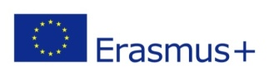 | ERASMUS+ PROGRAMME  INTERNATIONAL CREDIT MOBILITY / CALL 2019  STA –Staff Mobility for Teaching

CONFIRMATION
STAFF MEMBER
Family Name
First Name

SENDING INSTITUTION
Name of sending institution
Erasmus ID Code or City

RECEIVING INSTITUTION
Name of receiving institution | Agricultural University of Athens
Erasmus ID Code | G ATHINE03

This is to certify that the above mentioned person has attended our University under the conditions and terms set by the
Erasmus+ Programme /International Credit Mobility / Staff Mobility for Teaching
from …………………… till …………………… (Academic year ………-……….)
and has fulfilled all activities provisioned in the Mobility Agreement mutually concluded by the two Institutions.

Date:

Professor Serkos Haroutounian, Vice Rector of AUA
Erasmus+ Institutional Coordinator

