Agricultural University Of Athens

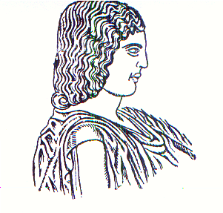
European Programmes Office
75, Iera Odos str., 118 55 Athens
HELLAS (Greece)

Erasmus+ Student Questionnaire

NAME OF THE STUDENT: ………………………………………………………………………………………….
Home University: ……………………………………………………………………………………..
Duration of stay at AUA: …………...… (months), From ……. .…….. Until… ……
Academic Year: …………………………………………………………………… …………………
Academic Programme: Courses  Research Project  Other 
Faculty/department/laboratory of studies at AUA: …………………………………
………………………………………………………………………………………………………………..

Describe your impressions from the academic life at the AUA (organization of studies, academic level, personal benefits, etc):
…………………………………………………………………………………………….……………..…..
…………………………………………………………………………………………….……………..…..
…………………………………………………………………………………………….…………..……..
…………………………………………………………………………………………….…………..……..
…………………………………………………………………………………………….…………..……..
…………………………………………………………………………………………….…………..……..

Describe your impressions from life in athens:
…………………………………………………………………………………………….………..………..
…………………………………………………………………………………………….………..………..
…………………………………………………………………………………………….………..………..
…………………………………………………………………………………………….…………..……..
…………………………………………………………………………………………….…………..……..
…………………………………………………………………………………………….…………..……..

What do you think about the whole erasmus+ mobility programme? Would you suggest to students of your university to participate? (please justify your reply)
…………………………………………………………………………………………….……………..…..
…………………………………………………………………………………………..….………………..
…………………………………………………………………………………………..….………………..
…………………………………………………………………………………………..….………………..
…………………………………………………………………………………………..….………………..
…………………………………………………………………………………………..….………………..

What kind of suggestions would you make to a future erasmus+ student from your country and university?
…………………………………………………………………………………………..….………………..
…………………………………………………………………………………………..….………………..
…………………………………………………………………………………………..….………………..
…………………………………………………………………………………………..….………………..
…………………………………………………………………………………………..….………………..
…………………………………………………………………………………………..….………………..

What special moments come into your mind when you think back of your erasmus+ mobility experience?
………………………………………………………………………………………..…….………………..
………………………………………………………………………………………..…….………………..
………………………………………………………………………………………..…….………………..
………………………………………………………………………………………..…….………………..
………………………………………………………………………………………..…….………………..
…………………………………………………………………………………………..….………………..

Please be spontaneous and sincere!!!

I accept that parts of the answers can be used in an information material

(SIGNATURE OF THE STUDENT)

