HELLENIC REPUBLIC
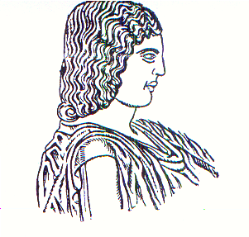

AGRICULTURAL UNIVERSITY OF ATHENS

EUROPEAN PROGRAMMES’ OFFICE

Address : 75 Iera Odos, 118 55 Athens, HELLAS (GREECE)

Tel. : +30 210 529 4819

E-mail : european_pr@aua.gr
Info : Ms. Thania Anastopoulou

Athens, ……………
Ref. No….

Certification of Erasmus+ Studies

This is to confirm that Mr./Ms. ……………………, student of the ……………… (Sending University and Country) has been enrolled at the Agricultural University of Athens in the framework of Erasmus+ International Credit Mobility Program for studies during the Academic Year …………………………...

Actual dates of the start¹ and the end² of the study period:

from ………………… to …………...

Professor N. DERCAS

Vice Rector of A.U.A.

Erasmus+ Institutional Coordinator

¹ First day the student has been present at the receiving institution for academic reasons (e.g. orientation week/day, the first course, language and intercultural training etc)
² The last day the student has been present at the receiving institution for academic reasons e.g. the end of exams period, courses etc) and not the actual date of departure.

