|  |
| --- |
|  |
|  |

STUDENT GUIDE 2025

For Erasmus Students

Contents

Welcome to the Agricultural University of Athens 3

A brief historical background of the Agricultural University

of Athens 3

The Agricultural University of Athens today 4

The Department of Agribusiness & Supply Chain

Management 4

Arriving at the Agricultural University of Athens (Athens campus) 5

Arriving at the Agricultural University of Athens (Thiva

campus) 5

Courses, Examinations, Grading of Qualification 6

University Registration 6

Health Care 6

Coordinators 7

Student’s Guide 8

Useful Telephone Numbers 10

2

# Welcome to the Agricultural University of Athens

The Agricultural University of Athens (A.U.A.) is the place that makes the difference and the new environment where you may pass a part of your study Programme combining the experience you already have with the new one. All the staff of the A.U.A. is willing to help you to integrate from the very beginning till the end of your stay. Moreover, we hope that the variety of Faculties initiated by the A.U.A. is going to respond to your expectations and your specific interests.

Dear student,

The A.U.A. welcomes you and wishes you a successful Erasmus study period and an unforgettable stay in Greece. Looking forward to meeting you, we give you some practical information you may need before your arrival and during your stay in Greece.

# A brief historical background of the Agricultural University of Athens

The Agricultural University of Athens is the third oldest University of Greece and the first devoted to agriculture. Its history goes back to 1920 and its impact on the development of Greek agriculture has been very significant.

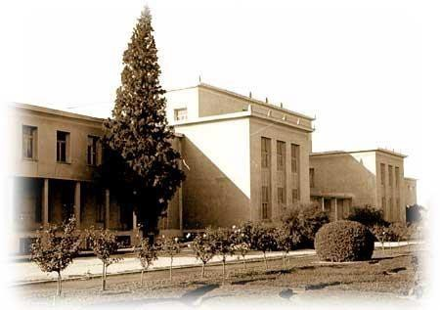

The historic location of its Athens campus near Kerameikos and along Iera Odos, the oldest street of Europe, is inseparably linked to the ancient Greek traditions of agriculture. Iera Odos was the route along which the ritual procession to worship Demeter, the goddess of agriculture, passed to end in Elefsina, the town of Triptolemos, who spread agriculture throughout Europe.

3

# The Agricultural University of Athens today

Nowadays, the A.U.A. has more than 200 teaching and research staff, approximately 2,000 students plus associated administrative and technical personnel. The University is actively involved in the promotion of research and teaching in collaboration with other institutions. It comprises 9 Departments and awards 9 undergraduate degrees in:

1. Crop Science
2. Animal Science
3. Biotechnology
4. Agricultural Economics & Rural Development
5. Food Science & Human Nutrition
6. Natural Resources Management & Agricultural Engineering
7. Forestry & Natural Environment Management (campus in Karpenisi)
8. Regional & Economic Development (campus in Amfissa)
9. Agribusiness & Supply Chain Management (campus in Thiva)

Most Departments of A.U.A. have initiated postgraduate programmes which lead to M.Sc. as well as Ph.D. degrees.

# The Department of Agribusiness & Supply Chain Management

The [Department of Agribusiness and Supply Chain Management](https://w1.aua.gr/agribusiness/en/department/) belongs to the School of Applied Economics and Social Sciences of the Agricultural University of Athens and is located in Thiva (Thebes). The Department was established in 2019 constituting the evolution of the Department of Logistics Management.

The Mission of the Department is to provide educational, research and scientific work of high quality in the areas of “Agribusiness Management” and “Supply Chain Management”, combining areas of study / disciplines within the domains of Business Organization and Administration, Supply Chain Management, Economics, and Agriculture / Agronomy with Basic Sciences.

The Department has developed a modern five-year curriculum, which offers its students both theoretical and applied scientific knowledge. Graduates will be awarded an Integrated Master’s degree. (Hellenic Authority of Higher Education is expected to approve the award of the Integrated Master’s degree).

Up to now, the Department offers a biinstitutional postgraduate programme of studies leading to a Master's Degree (M.Sc.) in “Techno-economic Systems Management” coordinated by the Department of Business Administration, National and Kapodistrian University of Athens. The Department also supports PhD students and postdoctoral researchers.

4

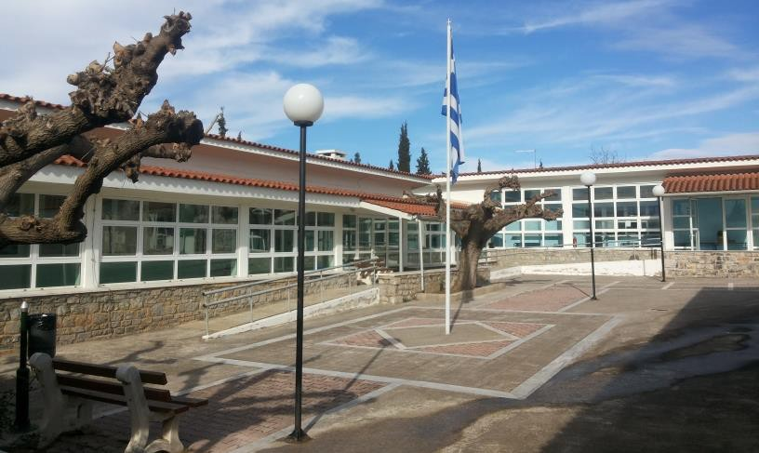

The Department presents dynamic development prospects, which are supported through the enhancement of its research activity, as a coordinator or partner, within both National and European research programmes. The Department is connected with productive companies and organizations located in the nearby industrial areas of Schimatari and Oenophyta, as well as the Attica region (e.g., the Thriassian Plain and the port of Piraeus), creating a strong networking grid with professional and scientific bodies as well as the local government administration agencies. The dynamic development trajectory of the Department is expected to be supported by the establishment of the “Center for Innovative and Sustainable Applications of Agricultural Sciences”, the result of a pertinent Protocol of Co-operation co-signed by the Agricultural University of Athens and the Administrative Region of Sterea Ellada (Mainland Greece).

# Arriving at the Agricultural University of Athens (Athens campus)

In order to arrive to the A.U.A. campus in Athens you can use a number of buses whose numbers are the followings: 813, 856, Α16, 026, 027. For more information on bus routes visit <https://www.osy.gr/>[.](http://www.oasa.gr/uk/index_gr.asp) In addition you may use the metro (Line 3): stations “Kerameikos” and “Eleonas”. For more information on metro routes visit (<https://www.stasy.gr/>.

# Arriving at the Agricultural University of Athens (Thiva campus)

In order to arrive to the A.U.A. campus in Thiva you can use a bus (KTEL) or train. The Athens to Thiva bus departs from “KTEL Liosion” and can take you directly to the campus (about 80 minutes travel time). Athens to Thiva train services, operated by Hellenic Train, depart from Athens station. Of course, if you decide to stay in Thiva you can reach the campus on foot.

5

# Courses, Examinations, Grading of Qualification

Studies at the A.U.A. last 5 years (except for the programme in Regional & Economic Development) and its courses are divided in two annual semesters (autumn and spring). Lessons include lectures and laboratory work.

The grading scale used in the A.U.A. is the following:

* Type of scale 1-10
* Highest grade 10
* Lowest passing grade 5

## EUROPEAN CREDIT TRANSFER SYSTEM

A: 9 – 10 EXCELLENT – outstanding performance with only minor errors B: 8 VERYGOOD - above the average standard but with some errors C: 7 GOOD - generally sound work with a number of no table errors D: 6 SATISFACTORY - fair but with significant shortcomings

E: 5 SUFFICIENT - performance meets the minimum criteria

Fx: 3-4 FAIL - some more work required before the credit can be awarded F: 1-2 FAIL – considerable further work is required

# University Registration

Upon their arrival in Greece, Erasmus students should visit the International Relations and Mobility Office in Athens and register. The Office will provide them with the Student Identity Card, the Restaurant Card (for Athens) and the Library Borrowing Card, valid for the period of study at the A.U.A.

The International Relations and Mobility Office is located on the ground floor of the University’s Central Administration Building (corridor of Laboratory of Agronomy) and it is open on Monday, Wednesday and Thursday from 10:00 to 12:00.

Address: Agricultural University of Athens, Department of International Relations and Mobility, 75, Iera Odos str, 118 55 Athens, tel: +30 210 5294819-823-927, e-mail: [european_pr@aua.gr).](mailto:european_pr@aua.gr)

# Health Care

All students of European Union are entitled to free medical care in Greece on presentation of an E128 (the ex E111) form. Students from other countries must be provided with a public or private insurance from their country of origin before entering Greece.

In case of emergencies the appropriate services to call are listed below.

6

For accidents or other medical emergencies, a 24-hour ambulance service operates within Athens (Call 166 - nationwide emergency). If necessary, patients can be transferred to EOPYΥ (Greek National Health Service System – Εθνικός Οργανισμός Παροχής Υπηρεσιών Υγείας) hospitals. A complete list of ESY hospitals, private hospitals and clinics is available here: [http://www.eopyy.gov.gr](http://www.eopyy.gov.gr/).

Greek pharmacies are highly qualified and cannot only advise on minor ailments, but also dispense medication. Their premises (“farmakeia – φαρμακεία“) are identified by a red or green cross on a white background. Pharmacies are open following shopping hours. Details are posted in pharmacy windows, both in Greek and in English.

# Coordinators

### Erasmus Institutional Coordinator

Professor Emmanouil Flemetakis, Vice Rector (Rectory, Central Building, 2nd floor)

Tel: +30 210 5294802, e-mail: [**vr2@aua.gr**](mailto:vr2@aua.gr)

### Department of Agribusines and Supply Chain Management (campus in Thiva)

*Departmental Coordinator*: Associate Professor Ioannis Tsoulfas e-mail: [**giannis@aua.gr**](mailto:giannis@aua.gr)

*Deputy Departmental Coordinator:* Assistant Professor Kanellos Tountas, e- mail: [**kstoudas@aua.gr**](mailto:kstoudas@aua.gr)

### CONTACT FOR ADMINISTRATION ISSUES

Ms. Thania Anastopoulou, Head of the Department

Tel. +30 210 529 4819, e-mail: [european_pr@aua.gr](mailto:european_pr@aua.gr) Ms. Vicky Griva

Tel. +30 210 529 4823, e-mail: [european_pr@aua.gr](mailto:european_pr@aua.gr)

*Address:*

Agricultural University of Athens

Directorate of Internationalization, Mobility and Student Welfare

Department of International Relations & Mobility

75, Iera Odos str., 118 55, Athens, GREECE

[Find us](http://www.aua.gr/media.php?file=docs/european/findus.jpg) at the ground floor of the Central Building (No 1, corridor of Laboratory of Agronomy)

*OPENING HOURS:* Monday, Wednesday and Thursday 10 am to 13 pm

For more information about your Erasmus in AUA visit: <http://www.european.aua.gr/?page_id=757>

and ESN AUA Athens website:

<http://aua.esngreece.gr/>

# Student’s Guide

## ARRIVING AT THE ATHENS INTERNATIONAL AIRPORT “ELEFTHERIOS VENIZELOS”

The Athens International Airport is located 44 km north-eastern of Athens and can be rapidly accessed via a six-lane motorway ("Attiki Odos"), by express busses on a 24h basis [(](http://www.oasa.gr/)<https://www.osy.gr/>[)](http://www.oasa.gr/), by metro and Suburban Railway (<https://www.stasy.gr/>[)](http://www.proastiakos.gr/) from Athens center and the port of Piraeus, ensuring this way efficient transport of air travelers and facilitating linkage to key tourist attractions.

## PUBLIC TRANSPORT IN ATHENS

The unified ticket is valid for all transportation in all means of Mass Transportation (metro, tram, buses, trolley-buses) for unlimited rides for 90 minutes from the time of its validation. You should validate your ticket upon boarding on the vehicle (bus, trolley-busses) or entering the station (metro, tram) or possess a valid transportation card (daily, weekly, monthly, yearly). You can buy tickets in all stations and in kiosks (periptera).

## TAXIS

Taxis can be found at special stops or in motion. Between 24:00 and 5:00 there is a double tariff. The amount payable is indicated on the taximeter of the car, except in cases where there is an extra charge (transport from ports – airports, long distance bus terminals, luggage, radio – taxi call). During Christmas and Easter period there is usually an extra charge.

## LONG DISTANCE TRANSPORTATION

You can travel by long – distance buses (KTEL) throughout Greece.

## LOCAL CURRENCY, BANK SERVICES AND CREDIT CARDS

The monetary unit in Greece is Euro

Coins : 0,01 / 0,02 / 0,05 / 0,10 / 0,20 / 0,50 / 1 / 2

Notes : 5 / 10 / 20 / 50 / 100 / 200 / 500

There are Greek banks and branches of all big foreign banks in all major towns and resorts as well as exchange facilities at post offices, travel agents, hotels, tourist offices and car hire agencies. Always take your passport with you when

8

cashing travelers’ checks and check exchange rates and commission charges beforehand, as they vary greatly. In major towns and tourist areas you may find a foreign exchange machine for changing money at any time of day or night; these operate in several languages. All banks are open from 08:00 to 14:30 Monday to Thursday and from 08:00 to 14:00 on Friday. Cash machines are in operation 24 hours a day. All banks are closed on public or national holidays.

The most widely accepted credit cards in Greece are Visa, MasterCard (Access), American Express and Diners Club. They are the most convenient way to pay for plane tickets, international ferry journeys, car hire, most hotels and large purchases.

## POLICE SERVICE

Greece’s police (“αστυνομία”) are split into 3 forces: the regular police, the port police and the tourist police. The tourist police are the most useful for holiday – makers, combining normal police duties with tourist advice. Should you suffer a theft, lose your passport or have cause to complain about shops, restaurants, tour guides or taxi drivers, your case should first be known to them. Usually, every tourist police office has at least one English speaker, they can act as translators if the case needs to involve the local police. Their offices also offer maps, brochures and advice on finding accommodation.

## MAIN PUBLIC HOLIDAYS

Educational institutions have two-week vacations during Christmas as well as during Orthodox Easter.

These are the dates when the A.U.A. and other public organizations are closed nationwide:

1st January (New Year's Day) 6th January (Epiphany Day)

30th January (only for Educational Institutions) 25th March (National Holiday)

Greek Orthodox Easter (Sunday and Monday - movable feast) 1st May (Labor Day)

Holy Spirit (movable feast)

15th August (Assumption of Virgin Mary) 28th October (National Holiday)

17th November (only for Educational Institutions) 25th December (Christmas Day)

26th December (Boxing Day)

9

## PLACES TO VISIT

You can find useful information and suggestions in the following websites: For Thiva: <https://www.visitthiva.gr/en/>

For Athens: <https://www.visitgreece.gr/mainland/attica/athens/>

# Useful Telephone Numbers

First Aid Station: 166 Police: 100

Tourist Police: 171

Fire Squad: 199

Poisoning Cases Centre: 210 7793777

10